What’s Happening in your Lodge
Stated Meetings:
- Sept. 3rd Lodge Meeting at 7pm
- Sept. 17th Lodge Meeting at 7pm
- October 1st Lodge Meeting at 7 pm
- October 15th Lodge Meeting at 7 pm

Emergent Communications
- 3rd Degree to be Announced

Future Events:
- Blood Drive September 11th
- Grand Lodge Sept. 24th – 26th
- Knights of Solomon October 17th
- York Rite Movie Night Oct 24th Open to everyone

Worshipful Master
Warren G. Taylor
252-671-1717
Wtaylor.20@outlook.com

Senior Warden Ed Butts, PM

Junior Warden Zach Carpenter

Treasurer Wayne Lytton, PM

Secretary Scott Waligora, PM

Senior deacon David Webb

Junior deacon Chuck Aldrich, PM

Senior Stewart Doug Jefferson

Junior Stewart Butch ricks, PM

Chaplin Danny Miller

Tyler Al Kucmierz

Trustee 1 Year Michael Best, PM

Trustee 2 Years Butch Ricks, PM

Trustee 3 Years Sam French, PM

Grand Master of Masons in North Carolina

Most Worshipful Steven M. Norris

District Deputy Grand Master
WB Bill Sanford
688mason@gmail.com

District Deputy Grand Lecturer
WB Charles W. Lytton
clytton1946@hotmail.com
Doric Lodge No. 568
Ancient Free & Accepted Masons
Chartered January 12, 1910

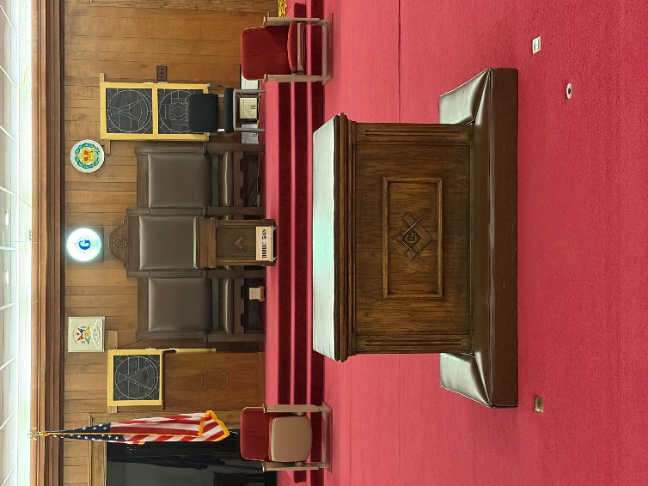

2100 S. Glenburnie Road
New Bern, North Carolina 28562

September/October 2026

Stated communication
1st & 3rd Thursdays each Month
6 pm Dinner / 7 pm Lodge
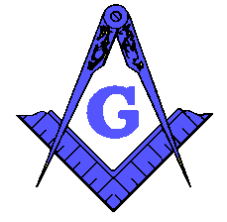
FROM THE EAST

Summer was here and Fall is upon us. I do hope everyone had a great summer and now it is time for things to pick up and get moving again. Labor Day will be on September 7th this year so our Lodge meeting on September 3rd will still be summer dress or polo’s if you wish.

We just had a Second Degree on August 13th so we will be doing a third sometime in mid to late September or early October. We will try to have this on a Saturday if possible since we will have 3 or more. This takes many people so please look for the date and come to our practices so we can Raise these brothers in the manner they deserve.

We are in the process once again keeping track of the items required for the Lion and Pillar award. We have not received any information on last year’s award, but I am sure we did well. We will find out just before or at Grand Lodge.

Our Masonic Education is going great and if you have not attended a meeting lately you need to check us out. I have a signup sheet on the bulletin board so you can share some of your knowledge with us as well.

Brotherly Love and Friendship will abound within our Lodge this year so please attend as often as you can, and I look forward to seeing you in our Lodge. If anyone needs assistance or a ride please contact me with your wishes.

Warren Taylor
Master

Family Day
If you did not make our first “Family Day” you missed a great day of fun for the whole family. We had a great response and look forward to another one next year. Here are a few photos of this year’s activities and Brothers and sisters who attended. The children had the most fun and what better way to spend the afternoon with family, friends, brothers and loved ones.

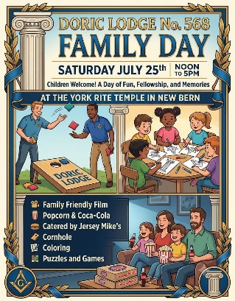

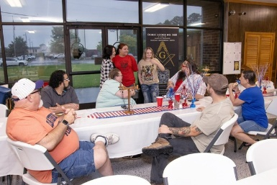

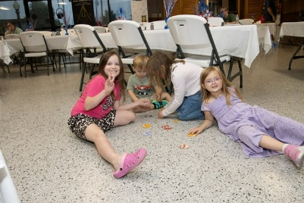

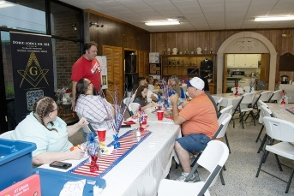

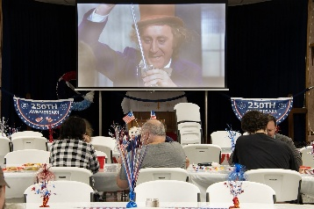

Our Living Past Masters
1979 Ernest C. Richardson, III
1981 David F. Gardner
1987 Steven J. Hill
1989 Larry A. Cooper
1990 Donnie R. Dixon
1991-2011 Thomas C. Williams
1995 Raymond C. Smith
1996 Daniel C. McDaniel
1997 John D. Lewis
1998-2006 Tull Wayne Register, Jr.
2000 Mark J. Dunham
2001 Alan H. Ritter
2002 G. William Linquist, Jr.
2007 Lorenzo J. Mares
2008 Iredell Camuel Wyatt, III
2012-2013 Charles D. Piner, Jr.
2015-2018 Ronald Ipock
2016 Donald Ipock
2017 Wayne Lytton
2019 Jerry L. Manning
2020 Ed Butts
2021 Scott Waligora
2022 David C. Mallard, Jr.
2023 Michael E. Best
2024 Ethridge “Butch” Ricks
2025 Samuel French

