Beulaville Masonic Lodge # 658

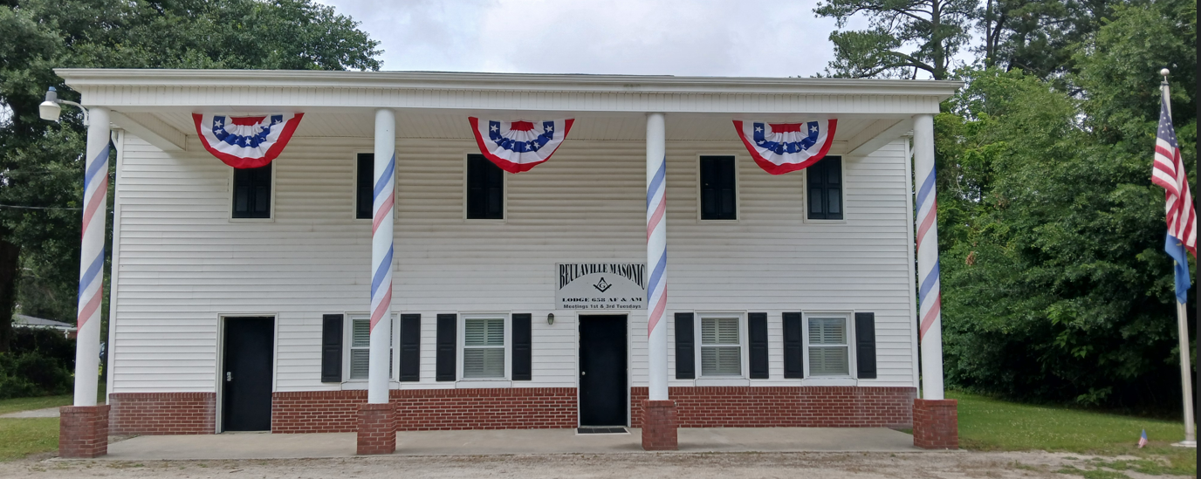

  - Our Lodge was chartered in 1923.
  - We meet on the first and third Tuesday of each month at 7:30 pm, with a dinner held at 6:30 pm prior to the first Tuesday meetings.

To the Brethan who are unable to attend our meetings. Please know we have missed your smile and your presence at our Lodge. Please know that your brothers are thinking of you, and may you feel the strength of our bond and the care of our prayers.

Birthdays and Anniversaries
Gary | Lee | Barrett | 8/12
Larry | Dean | Houston | 8/7
William | Edward | Humphries | 8/21
Joe | Harry | Lanier | 8/16
Genes | Lee | Norris | 8/3
Devan | Ferrell | Riley | 8/8
Herbert | Earl | Stroud | 8/29
Davey | Linwood | Thomas | 8/26


- Congratulations to those marking Masonic anniversaries this month. – Your commitment is appreciated.
 |  |  |  |  |  |  |  |  |  |  |  | Year of Service
Justin |  | Wright | Davis |  |  | 2015-08-04 |  |  |  | 11.02
Steven |  | Gregory | Howard |  |  | 1991-08-22 |  |  |  | 34.97
Cecil |  | Glenn | Lanier |  |  | 1972-08-01 |  |  |  | 54.02
Joe |  | Harry | Lanier |  |  | 1981-08-04 |  |  |  | 40.22
Stanley |  | Lafa | Miller |  |  | 1984-08-07 |  |  |  | 42.01

Reminders
- Dues for 2026 are now payable. Please remit your payment to the Lodge Secretary at your earliest convenience.
- If your contact information has changed, update the Secretary to ensure you receive all Lodge communications.

UPCOMING EVENTS

********************************************************************
The date for our annual Past Master / Widows Dinner will be August 15th @ 5PM. We will be recognizing all Past Masters, Widows and Veterans this year.
Guest Speaker will be Bobby Meadows Past Master of Zion Lodge No. 81, member Lux Libertas Lodge No. 772, Honorary member of Mt. Vernon Lodge No. 359, District Deputy Grand Master speaking upon Patriotism.

********************************************************************

Duplin County Shrine Club recently held a fraternal fish fry and made donations to the three Masonic Lodges in our County. Tuesday night August 4th Noble David Miller presented Beulaville Masonic Lodge WM Keith Hatcher a check for their portion of the proceeds.
This is exactly what Masonry looks like, giving back and strengthening the bonds that make our Masonic and Shrine families so special.
Thank you to everyone who came out, cooked, donated, supported, and helped make this event a success.
Proud to be a Shriner. Proud to be a Mason. Proud of Duplin County.

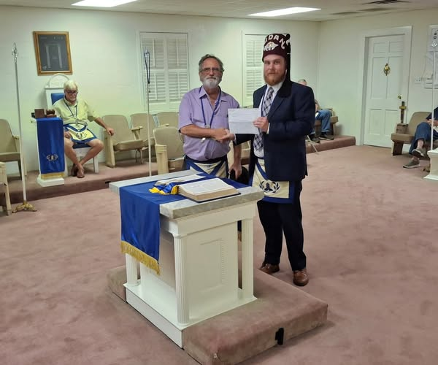

Beulaville Lodge Annual Golf Tournament
The Annual Golf Tournament will be held October 7th at Southern Wayne Golf Course.
We are currently seeking Teams, Door Prizes, and Hole Sponsors.
100% of our net income is donated directly to charitable causes.

Thank you for your continued involvement and support. Together, we build a stronger Lodge and community. We look forward to seeing you at this month's events.
Fraternally yours,
The Lodge Officers

WILLIAM KEITH HATCHAER MASTER 910-282-7817
WILLIAM DAVID MILLER SENIOR WARDEN 910-915-9675
GEORGE ANTHONY (TONY) MILLER JUNIOR WARDEN 910-915-9170
WILLIAM (BILL) GRESHAM RHODES SECRETARY 910-231-9745
DOUGLAS ALLEN TURNER TREASURER 910-296-4911

Beulaville Lodge #658 Feed Committees

Feb / Aug  Raymond Turner  Doug Turner  Benny Kennedy  Charles Turner  Dean Houston  Britt Dail | Mar / Sep  Justin Davis  Robert Jones  Craig Muller  Bruce Whaley  Matt Turner | Apr / Oct  Arthur Roe Jarman  Bill Rhodes  Hal Williams  Greg Houston  Gary Barrett  Joe Lanier  Doug Clark  Keith Hatcher
May / Nov  Art Edwards  Henry Parker  Genes Norris  Travis Raynor  Greg Norris  Joe Mobley | Jun / Dec  David Miller  Terry Williams  Tony Miller  Eddie Maready  Randy Scott  Matt Layell  Robert Canady | Jul / Jan  Lynn Mobley  Herbert Stroud  Eddie Humphries  Robert Robinson  Howard Cottle  Clifton Murphy



