What’s Happening in your Lodge
Stated Meetings:
- July 9th Lodge Meeting at 7pm
- August 6th Lodge Meeting at 7pm
- August 20th Lodge Meeting at 7 pm

Emergent Communication
- 2Nd Degree to be Announced
- 3rd Degree to be Announced

Future Events:
- York Rite Movie Night July 11th Open to everyone
- Certified Lecture Exam August 8th
- Cave Degree August 14 and 15 in Tennessee
- Joint Meeting with Zion Lodge 81 at Cherry Point Lodge 688 August 20th

Worshipful Master
Warren G. Taylor
252-671-1717
Wtaylor.20@outlook.com

Senior Warden Ed Butts, PM

Junior Warden Zach Carpenter

Treasurer Wayne Lytton, PM

Secretary Scott Waligora, PM

Senior deacon David Webb

Junior deacon Chuck Aldrich

Senior Stewart Doug Jefferson

Junior Stewart Butch ricks, PM

Chaplin Danny Miller

Tyler Al Kucmierz

Trustee 1 Year Michael Best

Trustee 2 Years Butch Ricks

Trustee 3 Years Sam French

Grand Master of Masons in North Carolina

Most Worshipful Steven M. Norris

District Deputy Grand Master
WB Bill Sanford
688mason@gmail.com

District Deputy Grand Lecturer
WB Charles W. Lytton
clytton1946@hotmail.com
Doric Lodge No. 568
Ancient Free & Accepted Masons
Chartered January 12, 1910

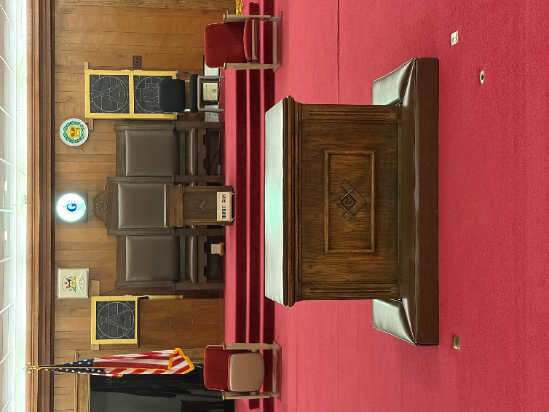

2100 S. Glenburnie Road
New Bern, North Carolina 28562

July/August 2026

Stated communication
1st & 3rd Thursdays each Month
6 pm Dinner / 7 pm Lodge
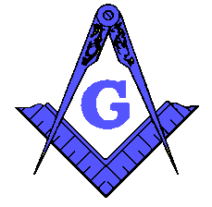
FROM THE EAST

Summer is here and in full swing. I hope everyone is enjoying the children while they are out of school or the Grandkids. Stay safe and enjoy your time with Family and friends.

We are still busy in the Lodge as we have just had a First Degree and are getting ready for a Second. A Third Degree will follow in the not to distance future.

We are in the process of submitting the goals we have accomplished for the Lion and Pillar Award. We should have enough to receive the platinum award. More on this subject in the coming weeks in the Lodge.

Our Masonic Education is going great and if you have not attended a meeting lately you need to check us out. I have a signup sheet on the bulletin board so you can share some of your knowledge with us as well.

Brotherly Love and Friendship will abound within our Lodge this year so please attend as often as you can, and I look forward to seeing you in our Lodge. If anyone needs assistance or a ride please contact me with your wishes.

Warren Taylor
Master

From The South
I’m looking forward to our upcoming EA and FC Degrees and watching our lodge grow. A lot of the newer brethren have been getting together for fellowship together, playing cards, going out for food, and more. Please reach out if you’d like to get together with us. Our June blood drive was a huge success; we blew our quota out of the water. We also should be in line to obtain the lion & pillar lodge of excellence award, thanks to the support of our Worshipful Master and dedicated Brethren. Stay tuned for info about our upcoming Family Day in July

Zach Carpenter
Junior Warden

From Gene Jenkins
The Masonic education program for the July stated meeting will be on the subject of Masonic influence on the birth of a nation. With the 250th anniversary of the ratification of the Declaration of Independence just 2 days after the meeting; I think you will find it both appropriate and quite interesting and you will be paid for your labors in US Currency.

From Your Treasurer

Brothers, thank you for supporting Doric Lodge in our lecture service on June 6th. It was well attended and I hope everyone had a good time and learned something. Sharing time with Berne Lodge was a pleasure in itself.

Wayne Lytton
Treasurer/Deputy Grand Lecturer

Our Living Past Masters
1979 Ernest C. Richardson, III
1981 David F. Gardner
1987 Steven J. Hill
1989 Larry A. Cooper
1990 Donnie R. Dixon
1991-2011 Thomas C. Williams
1995 Raymond C. Smith
1996 Daniel C. McDaniel
1997 John D. Lewis
1998-2006 Tull Wayne Register, Jr.
2000 Mark J. Dunham
2001 Alan H. Ritter
2002 G. William Linquist, Jr.
2007 Lorenzo J. Mares
2008 Iredell Camuel Wyatt, III
2012-2013 Charles D. Piner, Jr.
2015-2018 Ronald Ipock
2016 Donald Ipock
2017 Wayne Lytton
2019 Jerry L. Manning
2020 Ed Butts
2021 Scott Waligora
2022 David C. Mallard, Jr.
2023 Michael E. Best
2024 Ethridge “Butch” Ricks
2025 Samuel French

