Beulaville Masonic Lodge # 658

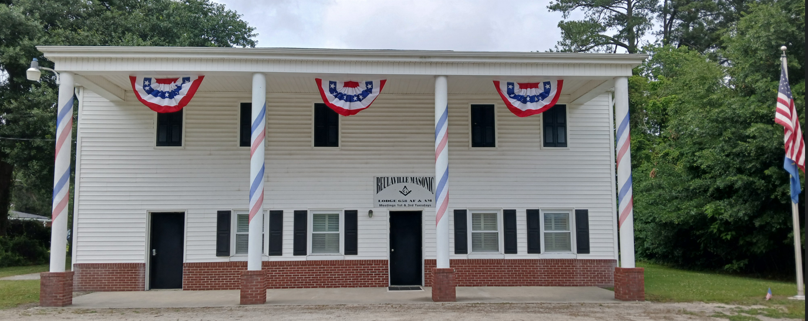

  - Our Lodge was chartered in 1923.
  - We meet on the first and third Tuesday of each month at 7:30 pm, with a dinner held at 6:30 pm prior to the first Tuesday meetings.

Master's Message
Thank you to all the brothers who helped with Bikes for Books, the Shriners’ Fish Fry, our Canned Food Drive, and decorating the Lodge in honor of Memorial Day, the Fourth of July, and America’s 250th Anniversary. Your dedication keeps our Lodge strong and our community proud.
Fraternally,
WM Keith Hatcher

To the Brethan who are unable to attend our meetings. Please know we have missed your smile and your presence at our Lodge. Please know that your brothers are thinking of you, and may you feel the strength of our bond and the care of our prayers.

Birthdays and Anniversaries
William | Miller | 6/25
James | Lanier | 6/20
Matthew | Layell | 6/27
Robert | Cannady | 6/14
Steven | Howard | 6/3
Lynn | Mobley | 6/2
Eddie | Kennedy | 6/30
Douglas | Clark | 6/27


- Congratulations to those marking Masonic anniversaries – your commitment is appreciated.
 |  |  |  | Years 0f Service
Britt |  | Dail | 1982-06-03 | 43.98
Shenandoah | Shane | Kennedy | 2007-06-05 | 18.98
William | David | Miller | 2013-06-25 | 12.92
Devan | Ferrell | Riley | 2017-06-16 | 8.94
Robert | Glenn | Robinson | 1994-06-07 | 31.97
William | Randall | Scott | 1982-06-22 | 43.89

Reminders
- Dues for 2026 are now payable. Please remit your payment to the Lodge Secretary at your earliest convenience.
- If your contact information has changed, update the Secretary to ensure you receive all Lodge communications.

Quick recap of our May Events for Beulaville Lodge #658.
Bikes for Books presentations were given to Beulaville Elem and Chinquapin Elem schools on May 8th. On Friday morning, May 15th, Bicycles were presented to BF Grady students’ winners for our Books for Bikes program. Also Friday we assisted Duplin County Shrine Club at our Beulaville Lodge for a Shriners Fish Fry and Saturday Morning we collected donations for East Duplin Christian Outreach Food Pantry. Shout out to Beulaville Community and Duplin County Shrine Club for your support! Bikes for Books presentations were given to Beulaville Elem and Chinquapin Elem schools on May 8th.

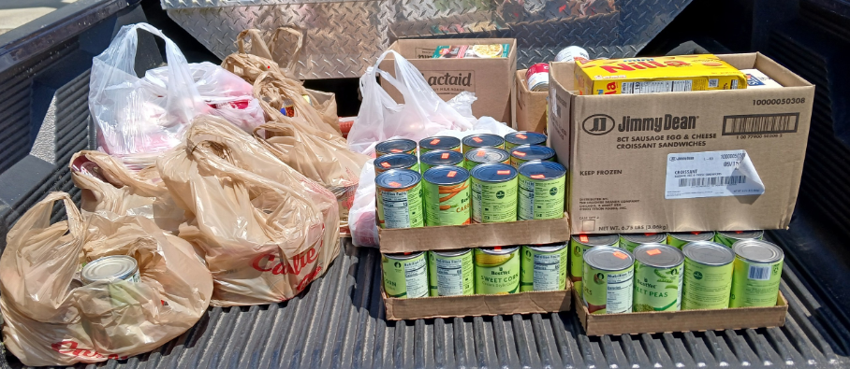



UPCOMING EVENTS
Kenansville St. John’s Lodge No. 13 will hold its Stated Communication on Thursday, July 2nd, which will also serve as their annual Fourth of July celebration. Beulaville Lodge No. 658 is honored to assist with this special event, and all Beulaville members and their guests are warmly invited to attend. This year’s celebration carries special significance as we join together to mark 250 years of American independence, commemorating the signing of the Declaration of Independence in 1776. The guest speaker for the evening will be Mr. Harvey Knowles of Wallace.
Dinner / Speaker at 6:30 PM ******Stated Communications at 7:30PM
********************************************************************
The date for our annual Past Master / Widows Dinner will be August 15th. Additional details will be shared as we get closer to the event.
********************************************************************

Beulaville Lodge Annual Golf Tournament
The Annual Golf Tournament will be held October 7th at Southern Wayne Golf Course.
We are currently seeking Teams, Door Prizes, and Hole Sponsors.
This is the largest fundraiser of the year for Beulaville Lodge, and your support truly makes a difference. Last year, thanks to the generosity of our teams and sponsors, we were able to donate $11,251.10 to four different charities.
100% of our net income is donated directly to charitable causes.
Please see attached Flyer

Thank you for your continued involvement and support. Together, we build a stronger Lodge and community. We look forward to seeing you at this month's events.
Fraternally yours,
The Lodge Officers

WILLIAM KEITH HATCHAER MASTER 910-282-7817
WILLIAM DAVID MILLER SENIOR WARDEN 910-915-9675
GEORGE ANTHONY(TONY) MILLER JUNIOR WARDEN 910-915-9170
WILLIAM(BILL) GRESHAM RHODES SECRETARY 910-231-9745
DOUGLAS ALLEN TURNER TREASURER 910-296-4911

Beulaville Lodge #658 Feed Committees

Feb / Aug  Raymond Turner  Doug Turner  Benny Kennedy  Charles Turner  Dean Houston  Britt Dail | Mar / Sep  Justin Davis  Robert Jones  Craig Muller  Bruce Whaley  Matt Turner | Apr / Oct  Arthur Roe Jarman  Bill Rhodes  Hal Williams  Greg Houston  Gary Barrett  Joe Lanier  Doug Clark  Keith Hatcher
May / Nov  Art Edwards  Henry Parker  Genes Norris  Travis Raynor  Greg Norris  Joe Mobley | Jun / Dec  David Miller  Terry Williams  Tony Miller  Eddie Maready  Randy Scott  Matt Layell  Robert Canady | Jul / Jan  Lynn Mobley  Herbert Stroud  Eddie Humphries  Robert Robinson  Howard Cottle  Clifton Murphy



