What’s Happening in your Lodge
Stated Meetings:
- May 7th Lodge Meeting at 7pm
- May 21st Lodge Meeting at 7pm
- June 4th Lodge Meeting at 7 pm
- June 18th Lodge Meeting at 7 pm

Emergent Communication
- 1st Degree to be Announced
- 2Nd Degree to be Announced

Future Events:
- Blood Drive, Friday June 5th
- 5 Hour Lecture Service
- Scottish Rite Ring Ceremony June 13th Open to the Public
- York Rite Movie Night June 20th Open to everyone
- Certified Lecture Exam August 8th

Worshipful Master
Warren G. Taylor
252-671-1717
Wtaylor.20@outlook.com

Senior Warden Ed Butts, PM

Junior Warden Zach Carpenter

Treasurer Wayne Lytton, PM

Secretary Scott Waligora, PM

Senior deacon David Webb

Junior deacon Chuck Aldrich

Senior Stewart Doug Jefferson

Junior Stewart Butch ricks, PM

Chaplin Danny Miller

Tyler Al Kucmierz

Trustee 1 Year Michael Best

Trustee 2 Years Butch Ricks

Trustee 3 Years Sam French

Grand Master of Masons in North Carolina

Most Worshipful Steven M. Norris

District Deputy Grand Master
WB Bill Sanford
688mason@gmail.com

District Deputy Grand Lecturer
WB Charles W. Lytton
clytton1946@hotmail.com
Doric Lodge No. 568
Ancient Free & Accepted Masons
Chartered January 12, 1910

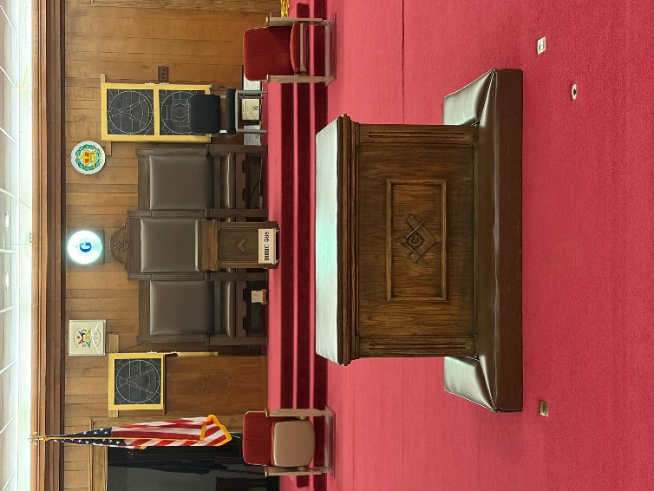

2100 S. Glenburnie Road
New Bern, North Carolina 28562

May/June 2026

Stated communication
1st & 3rd Thursdays each Month
6 pm Dinner / 7 pm Lodge
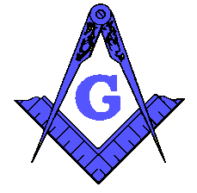
FROM THE EAST

It is so good to see so many of our members coming to lodge. Having our officers’ chairs filled and brothers on the sideline is wonderful to see.

We are making great strides in our lodge and for the first time we may obtain the Lion and Piller award from the Grand Lodge.

Our newly made Entered Apprentice has already returned his catechism and is waiting for the Fellowcraft Degree. We have two long time Entered Apprentices who will return their Catechism in May so we will be looking at a Second Degree in June. Also, we will have a possible First degree this Month as well.

I would like to invite everyone to our York Rite Movie on June 20th for all the Hamburgers and Hotdogs you can eat along with a great movie. This will be a family affair so bring the kids and have a great evening with family and friends.

Our Masonic Education is going great and if you have not attended a meeting lately you need to check us out. I have a signup sheet on the bulletin board so you can share some of your Knowledge with us as well.

Brotherly Love and Friendship will abound within our Lodge this year so please attend as often as you can, and I look forward to seeing you in our Lodge. If anyone needs assistance or a ride please contact me with your wishes.

Warren Taylor
Master

From Your Junior Warden
Brethren, it is with great pleasurer that our Lodge was able to fee at least 54 First Responders on April 15. They all enjoyed the meal and thanked us for taking the time out of our day to serve them. This was a great success, and I want to thank all who help with this project. St. John’s No. 3 also helped serve and I wish to thank them as well for their support.

Brothers, we now have a new Banner that really looks great and will be used for all Doric Lodge events. We are planning a Family Day in the coming months and if anyone has any ideas, please contact the Revitalization committee or reach out to me.

If you have time we have a book club that meets after the first meeting of the month and right now are towards the end of Solomon’s Builders by Christopher Hodapp.

Chad and I have been traveling to other lodges, and we would love to have others join us on these travels.

Zach Carpenter
Junior Warden

From Your Treasurer

Brother for those who may not know my wife passed away April 2nd. I want to thank all the brethren for their words of support, Prayers, and expressions or condolences during this time.

Our Living Past Masters
1979 Ernest C. Richardson, III
1981 David F. Gardner
1987 Steven J. Hill
1989 Larry A. Cooper
1990 Donnie R. Dixon
1991-2011 Thomas C. Williams
1995 Raymond C. Smith
1996 Daniel C. McDaniel
1997 John D. Lewis
1998-2006 Tull Wayne Register, Jr.
2000 Mark J. Dunham
2001 Alan H. Ritter
2002 G. William Linquist, Jr.
2007 Lorenzo J. Mares
2008 Iredell Camuel Wyatt, III
2012-2013 Charles D. Piner, Jr.
2015-2018 Ronald Ipock
2016 Donald Ipock
2017 Wayne Lytton
2019 Jerry L. Manning
2020 Ed Butts
2021 Scott Waligora
2022 David C. Mallard, Jr.
2023 Michael E. Best
2024 Ethridge “Butch” Ricks
2025 Samuel French

