Beulaville Masonic Lodge # 658
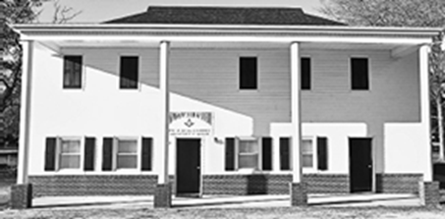

  - Our Lodge was chartered in 1923.
  - We meet on the first and third Tuesday of each month at 7:30 pm, with a dinner held at 6:30 pm prior to the first Tuesday meetings.

Master's Message
“First, I would like in thank God and all the Lodge Brothers who helped with the Beulaville Chamber of Commerce Hog Wild Event Cook-off. This coming month we have several events, Bikes for Books and the Shriner’s Fish Fry on the 15th. Our annual can food drive for the East Duplin Christian Outreach Pantry on the 16th.
Fraternally,
WM Keith Hatcher

To the Brethan who are unable to attend our meetings. Please know we have missed your smile and your presence at our Lodge. Please know that your brothers are thinking of you, and may you feel the strength of our bond and the care of our prayers.

Birthdays and Anniversaries

Shane Kennedy 05-14
Eddie Maready 05-15
Douglas Turner 05-30
Wishing you many more years of happiness and service.

- Congratulations to those marking Masonic anniversaries – your commitment is appreciated.
 |  |  |  | Years of Service
David | Howard | Cottle | 1989-05-02 | 36.98
Willy | Todd | Jenkins | 2010-05-04 | 15.98
Robert | Madron | Jones | 1989-05-02 | 36.98
John | Richard | Weston | 1966-05-12 | 59.96
Hal |  | Williams | 2005-05-03 | 20.98

Reminders
- Dues for 2026 are now payable. Please remit your payment to the Lodge Secretary at your earliest convenience.
- If your contact information has changed, update the Secretary to ensure you receive all Lodge communications.

EVENTS
Canned Food Drive May 16th
Time to clean out your pantry and donate.
Please stop by and donate, or just say hello to Lodge Brothers.
Volunteers are welcomed
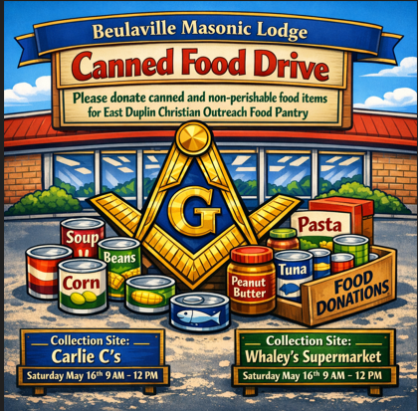

SHRINERS FISH FRY MAY 15TH

The Duplin County Shrine Club will have fraternal Fish Fry on Friday, May 15. They will be setting up at three locations that day; Duplin County Shrine Club in Wallace, Beulaville Lodge, and St. John's Lodge in Kenansville.

Plates will be $15.00 and include fish, slaw, boiled potatoes, and hushpuppies. We need to have your list of presale plates by Sunday, May 10 to place the fish order on Monday morning, May 11. Volunteers are needed

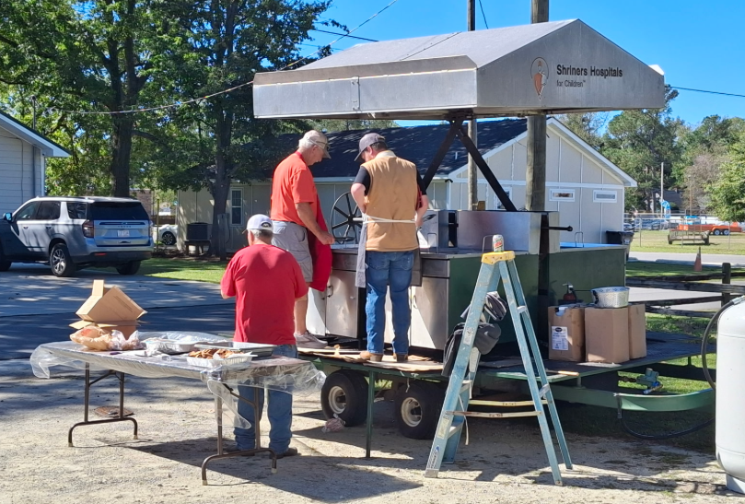


It’s essential to establish a love for reading early in life. Towards that end, Beulaville Lodge is happy to bring the Masonic Bikes for Books program to students throughout our Local Elementary schools.

Bikes for Books will be presented at the following schools on their Awards Day
Beulaville Elementary School May 8th 9:30 AM Chinquapin Elementary School May 8th 9:30 AM B.F Grady Elementary School May 15th 9:30 AM
All Masons are encouraged to participate in the presentation of Bikes to the Winners. If interested, please contact Bro Craig Muller 1-910-265-2165

In April we donated $250.00 to Beulaville Recreation Department, and our banner can be seen at the Beulaville Rec Ball Field.

Beautiful BBQ Hog cooked at Beulaville’s Hog Wild Event

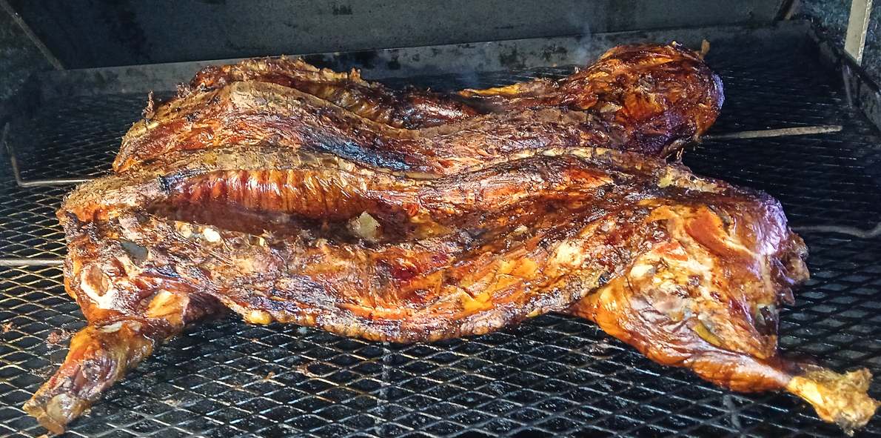

Thank you for your continued involvement and support. Together, we build a stronger Lodge and community. We look forward to seeing you at this month's events.
Fraternally yours,
The Lodge Officers

WILLIAM KEITH HATCHAER MASTER 910-282-7817
WILLIAM DAVID MILLER SENIOR WARDEN 910-915-9675
GEORGE ANTHONY(TONY) MILLER JUNIOR WARDEN 910-915-9170
WILLIAM(BILL) GRESHAM RHODES SECRETARY 910-231-9745
DOUGLAS ALLEN TURNER TREASURER 910-296-4911

Beulaville Lodge #658 Feed Committees

Feb / Aug  Raymond Turner  Doug Turner  Benny Kennedy  Charles Turner  Dean Houston  Britt Dail | Mar / Sep  Justin Davis  Robert Jones  Craig Muller  Bruce Whaley  Matt Turner | Apr / Oct  Arthur Roe Jarman  Bill Rhodes  Hal Williams  Greg Houston  Gary Barrett  Joe Lanier  Doug Clark  Keith Hatcher
May / Nov  Art Edwards  Henry Parker  Genes Norris  Travis Raynor  Greg Norris  Joe Mobley | Jun / Dec  David Miller  Terry Williams  Tony Miller  Eddie Maready  Randy Scott  Matt Layell  Robert Canady | Jul / Jan  Lynn Mobley  Herbert Stroud  Eddie Humphries  Robert Robinson  Howard Cottle  Clifton Murphy



