Beulaville Masonic Lodge No. 658
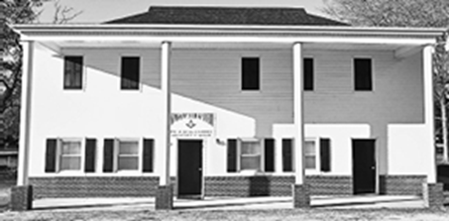

  - Our Lodge was chartered in 1923.
  - We meet on the first and third Tuesday of each month at 7:30 pm, with a dinner held at 6:30 pm prior to the first Tuesday meetings.

Master's Message
I would like to thank all of you for having confidence in electing me as Master of Beulaville Lodge 658. I believe that this year will have some great things happening, like the Widow/Past Master dinner, the annual Golf tournament, Annual can food drive and our Bikes for books program. This year we will also be inviting the Fire Department to eat with us on our first stated communication in April. We will also sponsor a Lodge Team in the Beulaville Hog Wild Cook Off.
Fraternally,
WM Keith Hatcher

To the Brethan who are unable to attend our meetings. Please know we have missed your smile and your presence at our Lodge. Please know that your Brothers are thinking of you, and may you feel the strength of our bond and the care of our prayers.

Birthdays and Anniversaries
Happy Birthday to Brothers celebrating this April
Hal Williams April 13
Jimmy Raynor April 13
Wishing you many more years of happiness and service.

- Congratulations to those marking Masonic anniversaries – your commitment is appreciated.
 |  |  |  | Years of Service
William | Keith | Hatcher | 2013-04-02 | 12.98
Larry | Dean | Houston | 1984-04-03 | 41.98
Arthur | Roe | Jarman | 1979-04-20 | 42.62
James | Jay | Lanier | 2017-04-04 | 7.39
Matthew | John | Layell | 2008-04-01 | 17.98
Michael | Joseph | Mobley | 2003-04-01 | 22.99
Ellis | Matthew | Turner | 2002-04-02 | 23.98

Reminders
- Dues for 2026 are now payable. Please remit your payment to the Lodge Secretary at your earliest convenience.
- If your contact information has changed, update the Secretary to ensure you receive all Lodge communications.

EVENTS
APPRECIATION MEAL FOR BEULAVILLE FIRE DEPARTMENT
APRIL 7TH 6:30 PM
Fire Department has been invited to join us for our feed night.

BEULAVILLE LODGE WILL BE A PARTICPANT IN BEULAVILLE HOG WILD COOK OFF
SATURDAY APRIL 18TH 2026
VOLUNTEERS ARE ENCOURGED TO JOIN OUR PIG COOKING TEAM.
PIG WILL BE COOKED FRIDAY NIGHT 17TH

CANNED FOOD DRIVE
We will have our annual Canned Food Drive on May 16th.
More info to come later.

It’s essential to establish a love for reading early in life. Towards that end, Beulaville Lodge is happy to bring the Masonic Bikes for Books program to students throughout our Local Elementary schools.

Thank you for your continued involvement and support. Together, we build a stronger Lodge and community. We look forward to seeing you at this month's events.
Fraternally yours,
The Lodge Officers

WILLIAM KEITH HATCHAER MASTER 910-282-7817
WILLIAM DAVID MILLER SENIOR WARDEN 910-915-9675
GEORGE ANTHONY(TONY) MILLER JUNIOR WARDEN 910-915-9170
WILLIAM(BILL) GRESHAM RHODES SECRETARY 910-231-9745
DOUGLAS ALLEN TURNER TREASURER 910-296-4911

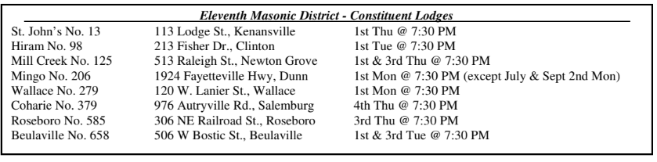

Beulaville Lodge #658 Feed Committees

Feb / Aug  Raymond Turner  Doug Turner  Benny Kennedy  Charles Turner  Dean Houston  Britt Dail | Mar / Sep  Justin Davis  Robert Jones  Craig Muller  Bruce Whaley  Matt Turner | Apr / Oct  Arthur Roe Jarman  Bill Rhodes  Hal Williams  Greg Houston  Gary Barrett  Joe Lanier  Doug Clark  Keith Hatcher
May / Nov  Art Edwards  Henry Parker  Genes Norris  Travis Raynor  Greg Norris  Joe Mobley | Jun / Dec  David Miller  Terry Williams  Tony Miller  Eddie Maready  Randy Scott  Matt Layell  Robert Canady | Jul / Jan  Lynn Mobley  Herbert Stroud  Eddie Humphries  Robert Robinson  Howard Cottle  Clifton Murphy



