2022 David C. Mallard, Jr.
2023 Michael E. Best
2024 Ethridge “Butch” Ricks
2025 Samuel French

What’s Happening in your Lodge
Stated Meetings:
- February 5th Lodge Meeting at 7pm
- February 19th Lodge Meeting at 7pm
- March 5th Lodge Meeting at 7 pm
- March 19th Lodge Meeting at 7 pm/Official Visit

Emergent Communication
- March 14Th 3Rd Degree 8 AM for Breakfast 9 AM for Degree
- 2Nd Degree to be Announced

Future Events:
- York Rite Festival March 7
- Scottish Rite Reunion and Degrees March 20 and 21
- Newport Pig Cooking Contest April 10, 11 and 12
- Sudan Spring Ceremonial April 24 and 25
- Down East Scottish Rite Club April 30
- Blood Drive, Friday June 5, 2026
Worshipful Master
Warren G. Taylor
252-671-1717
Wtaylor.20@outlook.com

Senior Warden Ed Butts, PM

Junior Warden Zach Carpenter

Treasurer Wayne Lytton, PM

Secretary Scott Waligora, PM

Senior deacon David Webb

Junior deacon Chuck Aldrich

Senior Stewart Doug Jefferson

Junior Stewart Butch ricks, PM

Chaplin Danny Miller

Tyler Al Kucmierz

Trustee 1 Year Michael Best

Trustee 2 Years Butch Ricks

Trustee 3 Years Sam French

Grand Master of Masons in North Carolina

Most Worshipful Steven M. Norris

District Deputy Grand Master
WB Bill Sanford
688mason@gmail.com

District Deputy Grand Lecturer
WB Charles W. Lytton
clytton1946@hotmail.com
Doric Lodge No. 568
Ancient Free & Accepted Masons

Chartered January 12, 1910

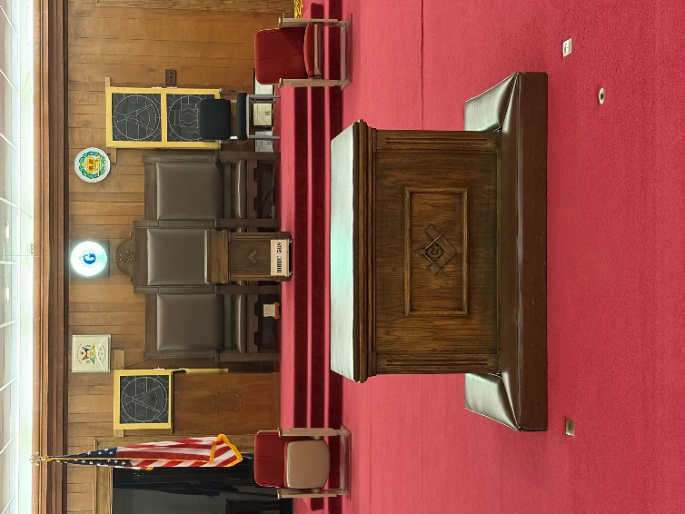

2100 S. Glenburnie Road
New Bern, North Carolina 28562

March/April 2026

Stated communication
1st & 3rd Thursdays each Month
6 pm Dinner / 7 pm Lodge
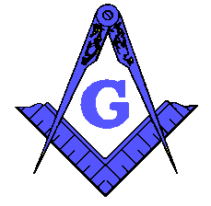
FROM THE EAST

As this year has gotten off on a fast start with degree work and new members learning their work, I feel we are making great strides in Doric Lodge. I am proud and Humbled to be your Master this year and it is my hopes that we can make this one of the best years on record as far as membership and attendance. It is my privilege to serve each and everyone of you as Master and if there are any suggestion or improvements we can make this year please bring them forward as all suggestions will be considered.

We have already had a First Degree by our newly installed Junior Warden who did an outstanding job. He will make this lodge a great Master in a few years.

I want to welcome back our Senior Deacon who has been recently reunited with the Lodge. I am so please with his work and progress after being absent for so long, Welcome back and let’s sing “We are the brothers of doric Lodge” more often.

Once again thanks to all the Brothers who have stepped up and taken a position. It is refreshing to see all of you at the meetings and the hard work you are doing.

Brotherly Love and Friendship will abound within our Lodge this year so please attend as often as you can, and I look forward to seeing you in our Lodge. If anyone needs assistance or a ride please contact me with your wishes.

Warren Taylor
Master

Our Past Masters
1910-11 Eward L. Gallis
1911-13-18-19 Ernest H. wood
1913-15 William T. Hill
1915-16 Noah F. Rowe
1916-17 Albert D. Brooks
1917-18-19-20 Charles A. Seifert
1920-22 Durwood H. Stallings
1922-23 William E. Rowe, Jr.
1923-24 John W. Overman
1924-25 George W. Allee
1925-26 Edward W. Paul
1926-27 John A. Howell
1927-28 Robert C. Whitley
1928-29 Graham A. Barden
1929-30 Garrison A. Farrow
1930-31 John C. Davis
1931-32 Frank R. Sitton
1933 T. Allen Buck
1934 Cyrus L. Powell
1935 E. Flynn Menus
1936 Floyd H. Foster
1937 Richard W. Brothers
1938 Clarence H. Barrow
1939 John C. Morton
1940 Samuel T. Cook
1941 Alfred H. Bremer
1942 Joseph W. Lewis
1943 James B. Holton
1944 Grover C. Phillips
1945 Robert L. Pugh
1946 John G. Ormsby
1947 Herbert W. Gillkin
1948 Clifton L. McCotter
1949 Charlie C. Rigsbee
1950 Henry F. Hill
1951 Ethridge H. Ricks
1952 William H. Scott
1953 Robert A. Gardner
1954 Clifford W. Heath
1955 Cecil E. Brown
1956 Carl L. Morton
1957 Charles F. Dickinson
1958 William L. Adams
1959 M.L. Weatherly
1960 Clarence W. Koonce
1961 Irving G. Weatherly
1962 Harry C. Soufas
1963 Charles E. Hill
1964 William T. Cahoon
1965 D. Elmo Jones
1966 Elwood E. Cayton
1967 William R. Waters
1968 Lee Roy Thomas, Jr.
1969 Max E. Bullard
1970 Jack G. White
1971 John R. Edwards
1972 Clifton E. Cayton
1973 Edward T. Moore
1974 Johnny R. West
1975 A. Keith Glover
1976 C. Phillip Nelson
1977-2009 Elmer R. Burroughs
1978 Jerry L. Stapleford
1979 Ernest C. Richardson, III
1980 Roy G. Fulcher
1981 David F. Gardner
1982 Royce E. Spain
1983 Wayne E. Cotey
1984 Alva J. Waters
1985 Melvin C. Tabler
1986 Lloyd E. Gaskins
1987 Steven J. Hill
1988 `Bruce E. Haddock
1989 Larry A. Cooper
1990 Donnie R. Dixon
1991-2011 Thomas C. Williams
1992 Charles L. Garris
1993 Clayton E. Burch
1994 Philip O. Lassiter
1995 Raymond C. Smith
1996 Daniel C. McDaniel
1997 John D. Lewis
1998-2006 Tull Wayne Register, Jr.
1999 Leonard O. Gatlin
2000 Mark J. Dunham
2001 Alan H. Ritter
2002 G. William Linquist, Jt.
2003 Bruce R. Arnold
2004 William B. Miller
2005-2010-2014 Alvin D. Bannister
2007 Lorenzo J. Mares
2008 Iredell Camuel Wyatt, III
2012-2013 Charles D. Piner, Jr.
2015-2018 Ronald Ipock
2016 Donald Ipock
2017 Wayne Lytton
2019 Jerry L. Manning
2020 Ed Butts
2021 Scott Waligora

