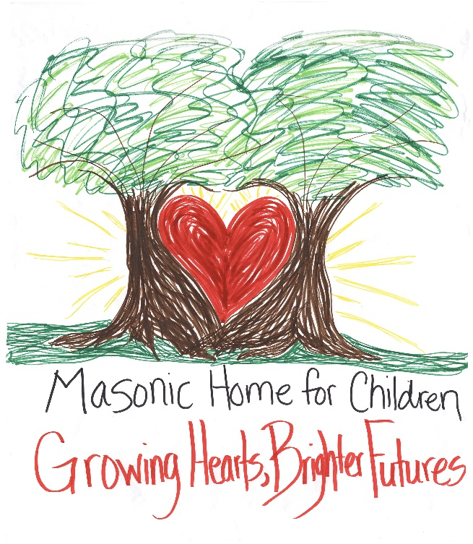

MHCO Wish List

** We are no longer accepting used items for the health and safety of our children and staff.**
**We need new, high quality items due to heavy usage.**

Items listed in Red are our most urgent needs!

Kitchen
- Large Electric Can Openers
- Pots and Pans Sets
- X-Large Step Trash Cans (30 gal)
- Drinking Glasses & Cups
- Silverware Sets
- Coffee Makers
- Kitchen Towels
- Dish Cloths
- Glass Food Storage Containers
- X-Large Griddles
- George Foreman Grills (X-Large)
- X-Large Electric Skillets
- Smoothie Makers
- Hand Mixers
- Cereal Containers
- Oven Mitts and Mats

Household

- Fabric Waterproof Mattress Covers (Twin, Twin XL, Queen)
- Bath Rugs
- Cloth Shower Curtains (Juvenile, Teenage)
- Shower Curtain Liners
- Bath Towels and Wash Cloths
- Bedding Sets (Twin & Twin XL)
- Sheet Sets (Twin XL)

- CD Players / Boom Box
- Batteries (AA, AAA)
- Shark Vacuum Cleaners
- Bedbug Mattress/Box Spring Encasements (Twin, Twin XL, Queen)
- Laundry Baskets
- Electric Alarm Clock Radios
- Clothes Hangers
- Televisions (Large Family Rm Size & 32”)

Hygiene

- Facial Wash
- Mouthwash (Alcohol Free)
- Toothpaste
- Floss picks
- Women’s Lotion
- Men’s & Women’s Deodorant
- Women's Razors
- Women's Shaving Cream
- Plastic Applicator Tampons
- Hand Soap (Pumps & Refills)

Misc.
- Ethnic Hair Care Products (Mixed Chicks, Cantu, Crème of Nature, Curly Kids, Shea Moisture, OGX)
- Men's 3n1 Body Wash
- Men's Lotion
- Men’s Body Spray
- Hairbrushes
- Shampoo & Conditioner (Dove, OGX, Garnier)
- Chapstick (Burt’s Bees, Carmex)

- Gas Grills, BlackStones & Covers
- Grilling Accessories
- LED Rope Lights
- Juvenile Bath Robes
- Ice Coolers
- Storage Containers (Medium, Large & X-Large)
- PS5, Xbox One Gaming Systems, Games & Wireless Controllers
- Carpet Shampooer
- Gift Cards (Walmart, Fast Food)
- Plastic Folding Tables (8 ft & 6 ft)
- Flashlights
- Men’s Wallets
- Nice Full-sized Bookbags
- Dorm Refrigerators
- Power Strips & Drop Cords
- Duffle Bags (Girls and Boys)

Thank You for Your Support!
(Please note that we are not currently accepting toys, blankets, clothes, scarves, hats, or youth gloves)

If you have any questions please feel free to contact our In-Kind Gift Coordinator, Leigh Ann Adcock,
ladcock@mhc-oxford.org (919)-603-3903

