To the Brothers of Winston Lodge #167,

I hope that this letter finds each of you and your families well. As we enter the 2025 year, I ask that the Grand Architect guides and continues to bless each of you. This letter is to extend gratitude and thankfulness for your continued contributions to Winston Lodge #167, past, present, and the future within the years to come, and to duly inform you of the Officers who have been installed for the ensuing year of 2025.

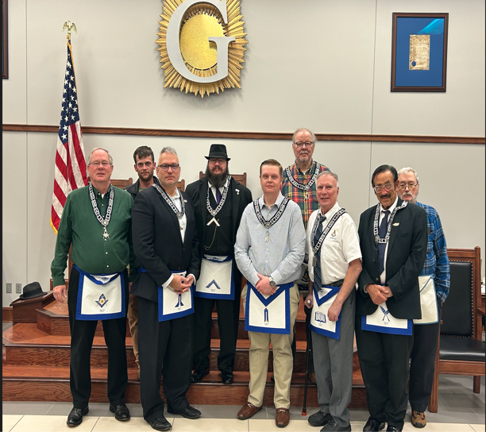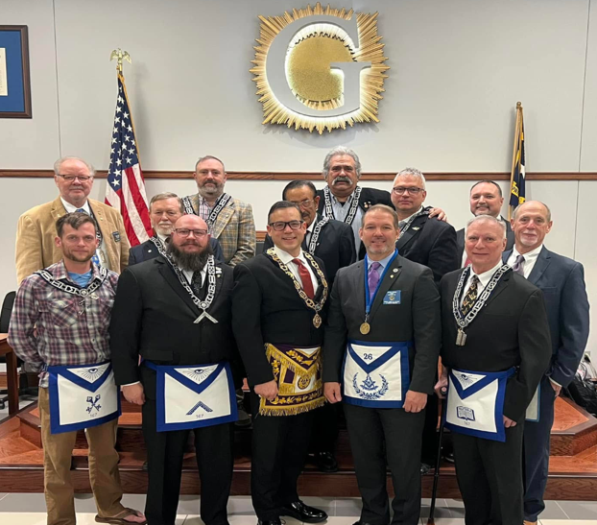

Brother Morgan Williams was elected and has graciously agreed with honor to serve as the Lodge Secretary. Brother Morgan is a Past Master presiding and serving the year of 1989 at Sinclair #154 of West Columbia, South Carolina. Brother Morgan has been serving as the Lodge Secretary since 2023.

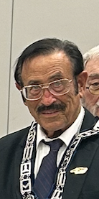

Brother Zackerie Dawson was elected and has graciously agreed with honor to serve as the Lodge Treasurer. Brother Zackerie is a Past Master presiding and serving the year of 2019 at King Lodge #722 of King, North Carolina. Brother Zackerie has been serving as the Lodge Treasurer since 2023.

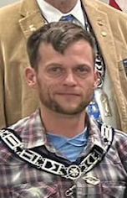

Brother Richard Miller has been appointed and graciously agreed with honor to serve as the Junior Deacon. Brother Richard Miller is a Past Master serving the following years of 2018 of Forsyth lodge #707 and again in 2019 and 2023 in Winston lodge 167 of Winston Salem, North Carolina. Brother Richard served the Lodge as Tiler in 2024.

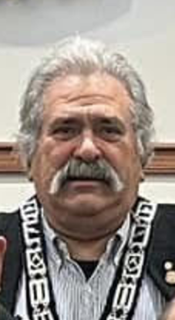

Brother Phillip Johnson has been appointed and graciously agreed with honor to serve as the Tiler. Brother Phillip Johnson is a Past Master serving the year of 2018 in Piedmont Pioneer Lodge #685 of Winston Salem, NC.

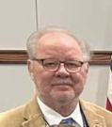

Brother Curtiss Scott has been appointed and graciously agreed with honor to serve as the Senior Deacon. Brother Curtiss served the lodge as the Junior Deacon in 2024.

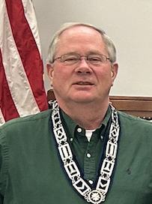

Brother Larry Toth has been appointed and graciously agreed with honor to serve as the Chaplain. Brother Larry Toth is a Past Master presiding and serving the following years of 2019 and 2020 in Forsyth Lodge #707 of Winston Salem, North Carolina, again in Piedmont
Pioneer Lodge #685 in 2019 in Winston Salem, North Carolina, and again in 2024 in
Winston lodge #167 of Winston Salem, North Carolina.

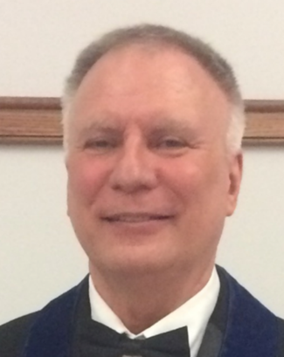

Brother Andrew Stuart has been elected and graciously agreed with honor to serve as the Junior Warden. Brother Andrew served the Lodge as Senior Deacon in 2024.

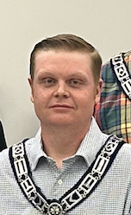

Brother Richard Lashley has been elected and graciously agreed with honor to serve as the Senior Warden. Brother Richard served the Lodge as Junior Warden in 2024.

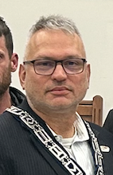
Brother Mark Wilson has been elected and graciously agreed with honor to serve as the Worshipful Master. Brother Mark served the Lodge as Senior Warden in 2024.

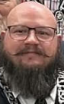

Attached to this letter you will find a tentative Lodge Agenda which is separated by the month for your information. As we begin to advance into 2025, I, with a humble heart sincerely want to say thank you for the opportunity to serve Winston Lodge #167, and also, remind each of you that Winston Lodge has a Stated Communication Meeting on the second Monday of each month starting with a meal at 1830 hours (6:30 pm) and the meeting at 1930 hours (7:30 pm) and encourage each of you if within the length of your cable tow to attend, enjoy fellowship and conduct Lodge business. Lastly, I ask that each of you support the Officers of the Lodge for the ensuing year of 2025. In conclusion, I ask that the Grand Architect of the Universe continue to bless each of us in our endeavors personally, professionally and as we continue to apply the principles, ethics, and morals of Freemasonry for the purpose of Faith, Hope, and Charity.

Sincerely and Fraternally,
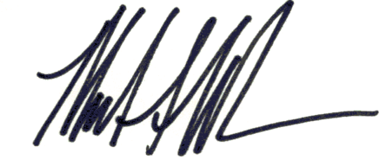
Mark Wilson
Worshipful Master 2025
Winston Lodge #167
2025 Tentative Lodge Agenda

- January
- January 4th, 2025 – Grand Master’s District Meeting
- January 18, 2025, 0900 hours 9 am until completion - 5 hour lecture – DDGL Jeff Bullington
- Visit Salem Lodge
- Masonic Education- Larry Toth

- February
- Rainbow Girls Meet and Greet
- Visit Clemmons Lodge
- Masonic Education - Richard Lashley

- March
- March 10th, 2025 - Guest Speaker - Mike Daniels
- Visit King Lodge
- March 15th, 2025 – School of Instruction – DDGL Jeff Bullington (option 1)

- April
- TBD - Masonic Center BBQ
- April 14th, 2025 – Guest Speaker - Mike Register
- TBD - Rainbow Girls fundraiser

- May
- Visit Old Town Lodge
- Mother’s Day Dinner and Rainbow Girls Fundraiser
- Masonic Education - Dan Sheets

- June
- Visit Walnut Cove Lodge
- June 14th, 2025 - 1st degree Red Letter Workshop 9 am – 12 pm – DDGL Jeff Bullington
- June 14th, 2025, 6 pm – 9pm - Father’s Day Dinner and Social Hour
- Masonic Education - Mark Wilson

- July
- July 5th, 2025 - 4th of July cookout
- TBD - Community event/Parade/Car Show- Bottled water station
- Masonic Education - Curtiss Scott
- TBD - Rainbow Girls fundraiser

- August
- Sponsor 2 students back to school supplies
- August 9th, 2025 - 2nd degree Red Letter Workshop 9 am – 12 pm – DDGL Jeff Bullington
- Masonic Education - Zackerie Dawson

- September
- September 8th, 2025 - Guest Speaker – Most Worshipful Past Grand Master Larry Thompson
- Visit West Bend Lodge
- September 6th, 2025, 6pm – 9 pm - Lodge Dinner and Social Hour
- Rainbow Girls fundraiser

- October
- TBD - Masonic Center BBQ
- October 4th, 2025 - 3rd degree Red Letter Workshop 9 am – 12 pm – DDGL Jeff Bullington
- Masonic Education - Richard Miller

- November
- November 15th, 2025 - MHCO event/Lodge Dinner and Social Hour/Rainbow Girls fundraiser 6pm – 9pm
- Masonic Education - Mark Wilson

- December
- December 8th, 2025 - Christmas Dinner – 6:30 pm to 7:30 pm (prior to Stated Communication)
- Sponsor a family for Christmas

