- 2024 Officers  Tim Walker - Master  336-516-2271  Joe Crane – Sen. Warden  919-593-1177  Michael Verville – Jr. Warden  919-278-0520  Ken Fath – Senior Deacon  Bronte Thompson – Junior Deacon  Jason Ross – Chaplain  WB Barry Deutsch – Tiler  Wade Winstead – Senior Steward  WB Al Serff – Junior Steward  WB Jim Cone - Treasurer  919-384-5305  WB Jeff Borcik - Secretary  919-370-1364  Lodge Info  Website: Eagle19.org  Email:  Eaglelodge19@gmail.com  Facebook  Eagle Lodge #19 AF&AM  P.O. Box 1095  Hillsborough NC 27278-1081 | Eagle Lodge # 19  AF & AM  142 West King St. Hillsborough NC 27278  P.O. Box 1095  Stated communications on the 2nd and 4th Tuesday of each month at 7:30 pm  Supper prior to each meeting at 6:30 pm  Please Join Us at the meal for fun and fellowship  Please text (RSVP) to JW Michael Verville – It helps with meal preparation  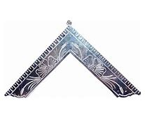  From the East  Greetings Brethren,  My time as Worshipful Master has run its course. I must say I have been truly honored to have been able to serve in this capacity. For me, it has been a busy, yet fun and rewarding year. The lodge has been active in the community on a number of projects and also busy with our Masonic work. We have raised 5 new brothers to the sublime degree of MM.  I would like to welcome these brothers to our wonderful fraternity.  Matt Brennan  Jamey Davidson  Joe Winecoff  Steven Witt  Jesse Wright  Welcome brothers, please know that you have joined one of the oldest and noblest fraternities in the world. I wish you much success in your Masonic Journey. If I can ever be of assistance, please let me know.  We held our annual officer elections last night for the ensuing year of 2025. I am happy to report that our progressive line kept right on progressing.  This is an outstanding group of Masons, and I know that Eagle Lodge #19 is in great hands. I am looking forward to seeing this leadership team in action in 2025.  The elected officers for 2025  Brother Joe Crane – Worshipful Master  Brother Michael Verville – Senior Warden  Brother Ken Fath – Junior Warden  Worshipful Brother Jim Cone – Treasurer  Worshipful Brother – Jeff Borcik – Secretary  Congratulations Brothers!  Thursday, December 19th at 6:30 pm we are going to have a Christmas dinner. Pot luck style. All are invited. Spouses and family welcome. Bring something good to eat and come on! I would love for you to join us!!  Pretty please with sugar on top, please come join us  So, in conclusion, and signing off from the East, I hope you all have a Merry Christmas, a Happy Holiday season, and I hope that 2025 is your best year yet.  Sincerely and fraternally,  Tim
  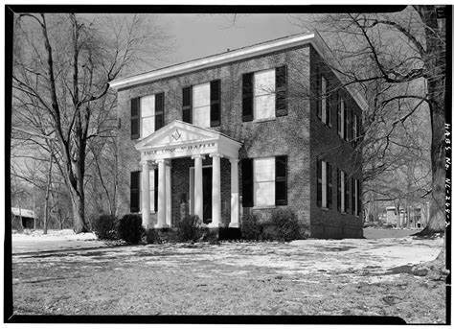
  Historic Eagle Lodge

Happy Birthday to all!

Rick Ashby 1st Jackie Medlin 5th

WB Jeff Borcik 12th Austin Cullins 14th

Claiborne Woods 15th Sri Arjuna Walsh 17th

WB Barry Deutsch 23rd Dustin Burnside 30th

Upcoming Events

*Pot luck Christmas dinner on 12/19 @6:30pm. Come and bring your spouse and family
Officer Installation 12/28 @2:00pm
Stated Communication 1/14/25

Sick and Distressed

Please continue to pray for the families of those affected by hurricane Helene.

Support our fundraiser
(This is an ongoing event, please keep selling)
One brick for $75 Two bricks for $140
Three for $205 Four for $275

How to Order:
Go to Eagle19.org to place your order. Be sure you are happy with your brick design as it will look very similar to the image on your computer when completed.
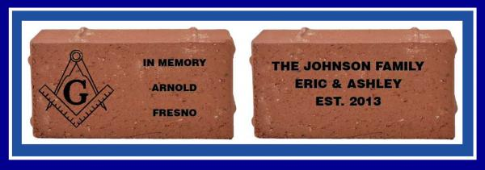

If you have any questions, please contact Barry Deutsch at barryid@gmail.com

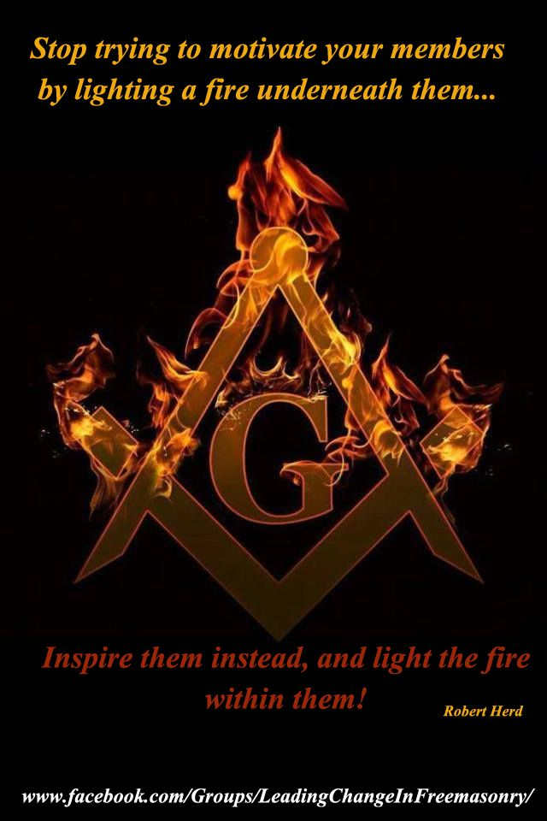
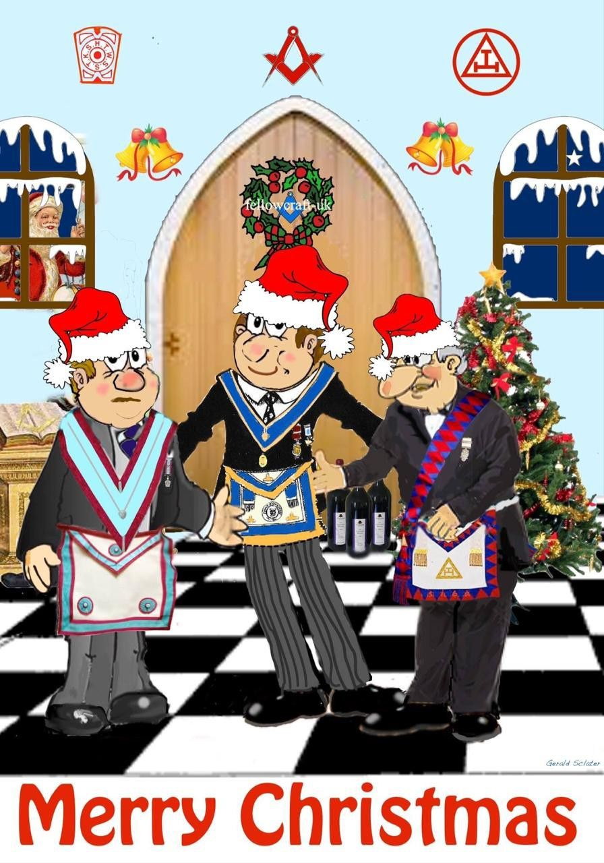

Never put off till tomorrow what you can do today.
Never trouble another for what you can do yourself.
Never spend your money before you have it.
Never but what you do not want, because it is cheap; it will be dear to you.
Pride cost us more than hunger, thirst, and cold.
We never repent of having eaten too little.
Nothing is troublesome that we do willingly.
How much pain have cost us the evils which have never happen.
Take things away by their smooth handle.
When angry, count to ten, before you speak; if very angry, a hundred.
-Thomas Jefferson

Each day I learn more than I teach;
I learn that half knowledge of another's life leads to false judgement;
I learn that there is a surprise kinship in human nature;
I learn that it is a wise father who knows his own son;
I learn that what we expect we get;
I learn that there is more good than evil in this world;
That age is a question of spirit;
That youth is the best of life;
No matter how numerous its years;
I learn how much there is to learn. -Virginia Church
I am not a teacher, but an awakener. -Robert Frost
There is no defense against an evil which only the victim and the perpetrator knows exist. -WRF
To awaken each morning with a smile brightening my face;
To greet the day with reverence for the opportunities it contains;
To approach my work with a clean mind;
To hold ever before me, even in the doing of little things,
the Ultimate Purpose toward which I am working;
To meet men and women with laughter on my lips and love in my heart;
To be gentle, kind, and courteous through all the hours;
To approach the night with weariness that ever woos sleep,
and the joy that comes from work well done-
This is how I desire to waste wisely my days. -Thomas Dekker
The secret of education lies in respecting the pupil. -Ralph Waldo Emerson

Raised 5 new brothers on November 23rd

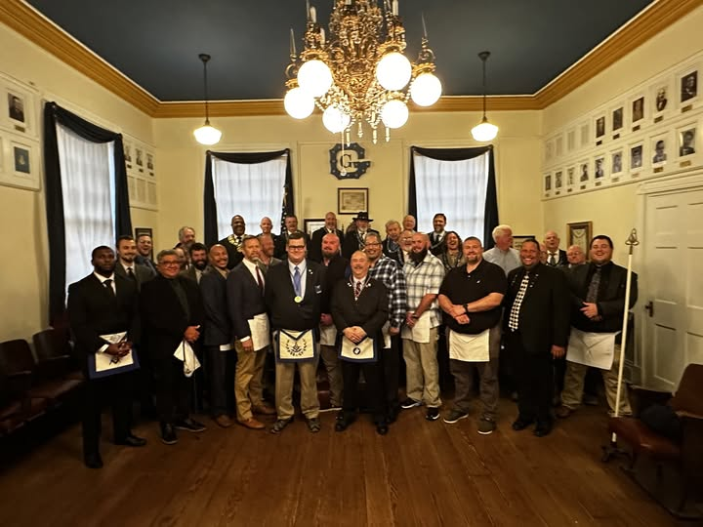
Most Worshipful Grandmaster Rideout visited Eagle Lodge on November 12th to present our
very own Past Grandmaster, MWB Speed Hallman, his 25-year service award



