- 2024 Officers  Tim Walker - Master  336-516-2271  Joe Crane – Sen. Warden  919-593-1177  Michael Verville – Jr. Warden  919-278-0520  Ken Fath – Senior Deacon  Bronte Thompson – Junior Deacon  Jason Ross – Chaplain  WB Barry Deutsch – Tiler  Wade Winstead – Senior Steward  WB Al Serff – Junior Steward  WB Jim Cone - Treasurer  919-384-5305  WB Jeff Borcik - Secretary  919-370-1364  Lodge Info  Website: Eagle19.org  Email:  Eaglelodge19@gmail.com  Facebook  Eagle Lodge #19 AF&AM  P.O. Box 1095  Hillsborough NC 27278-1081 | Eagle Lodge # 19  AF & AM  142 West King St. Hillsborough NC 27278  P.O. Box 1095  Stated communications on the 2nd and 4th Tuesday of each month at 7:30 pm  Supper prior to each meeting at 6:30 pm  Please Join Us at the meal for fun and fellowship  Please text (RSVP) to JW Michael Verville – It helps with meal preparation  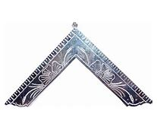  From the East  Greetings Brethren,  Hope you’re all doing well. The lodge continues to stay busy this year. We just completed a Habitat for Humanity work day. Tons of fun and very fulfilling.  This past Saturday, we jointly held a first responders’ breakfast with our brothers from Lux Libertas #772. It went very well and we had a good number of first responders participate. After the breakfast, Lux Libertas went upstairs and had their annual elections. The brothers from Eagle hung around and packed our shoe boxes for veterans.  Thursday, December 19th at 6:30 pm we are going to have a Christmas dinner. Pot luck style. All are invited. Spouses and family welcome. Bring something good to eat and come on! I would love for you to join us!!  Sincerely and fraternally,  Tim
  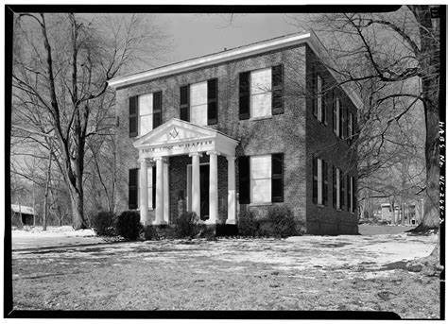
  Historic Eagle Lodge
 |            | Happy Birthday to all!  Dwight Riley 1st Alan Rosenberg 1st  Clyde Walker 7th Tommy Burel 10th  John Roberts 15th Daniel Jones 18th  WB Rory Swiggett 20th Michael Verville 26th  Upcoming Events  *Stated Communications on 11/12 and 11/26  *Grandmaster visit on the 12th and awarding MWB Speed Hall his 25-year award  *MM Degree on11/23 @1:00pm. Meal follows. Raising 5 brothers.  *Wardens night on the 26th Everyone moves up a chair.  *Pot luck Christmas dinner on 12/19 @6:30pm. Come and bring your spouse and family  Sick and Distressed  Please continue to pray for the families of those affected by hurricane Helene.  Pray for Mel Cone as she continues treatment.  Also pray for Brother Wade Winstead’s son. He has a major procedure coming up.  Support our fundraiser  (This is an ongoing event, please keep selling)  One brick for $75 Two bricks for $140  Three for $205 Four for $275  How to Order:  Go to Eagle19.org to place your order. Be sure you are happy with your brick design as it will look very similar to the image on your computer when completed.  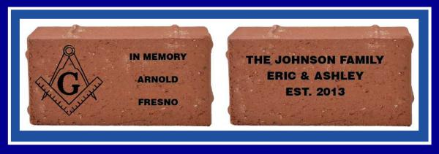  If you have any questions, please contact Barry Deutsch at barryid@gmail.com  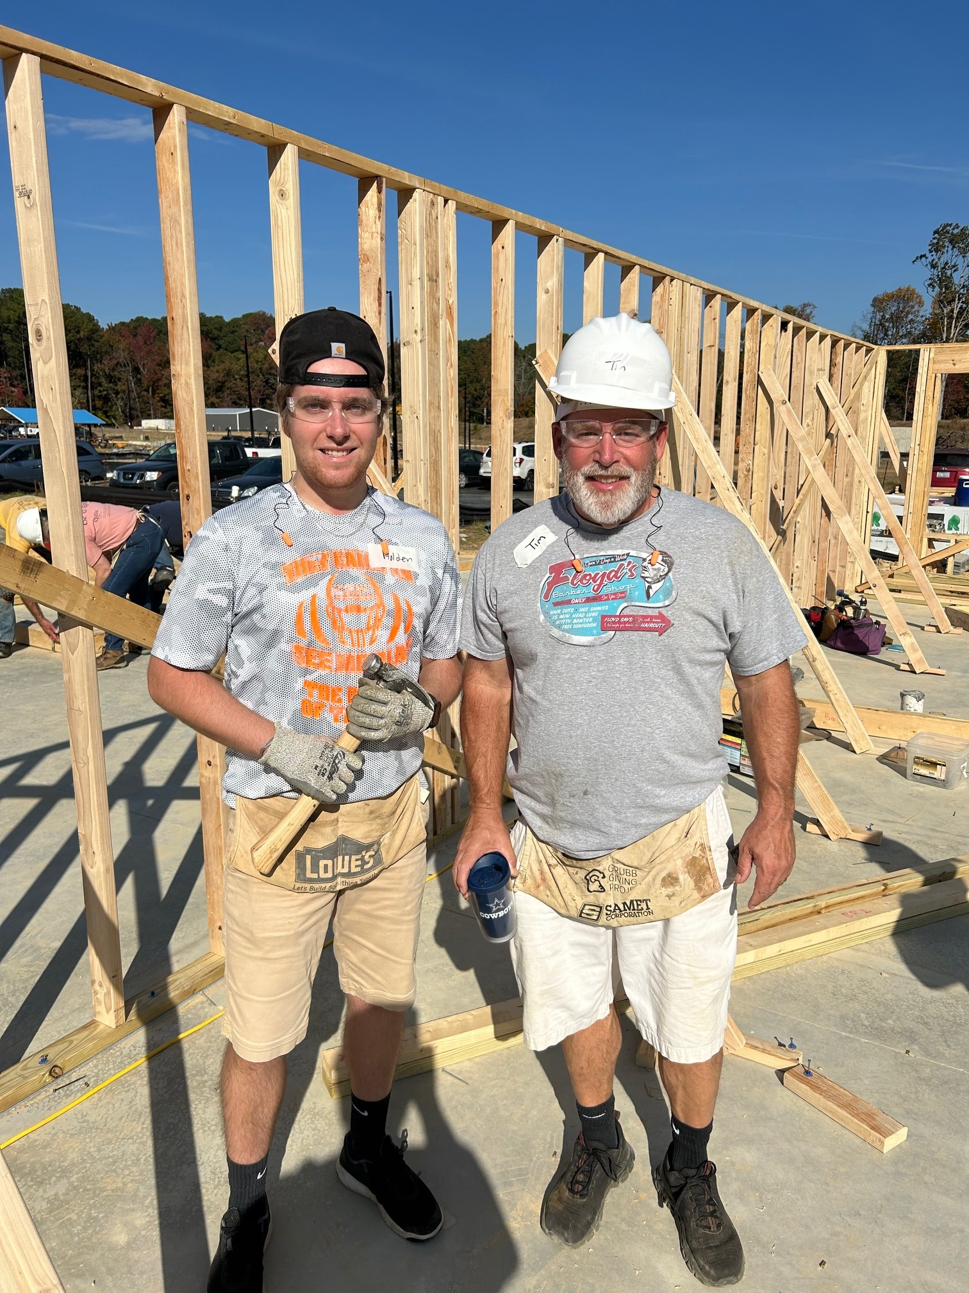  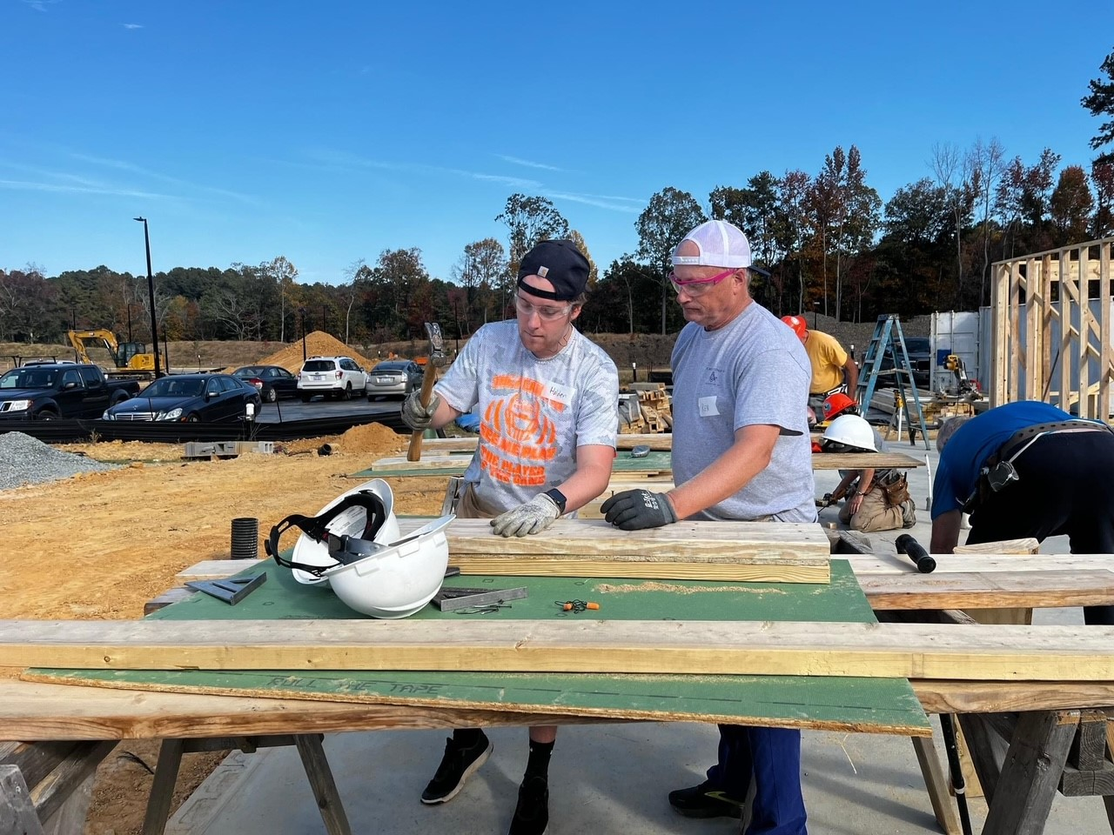  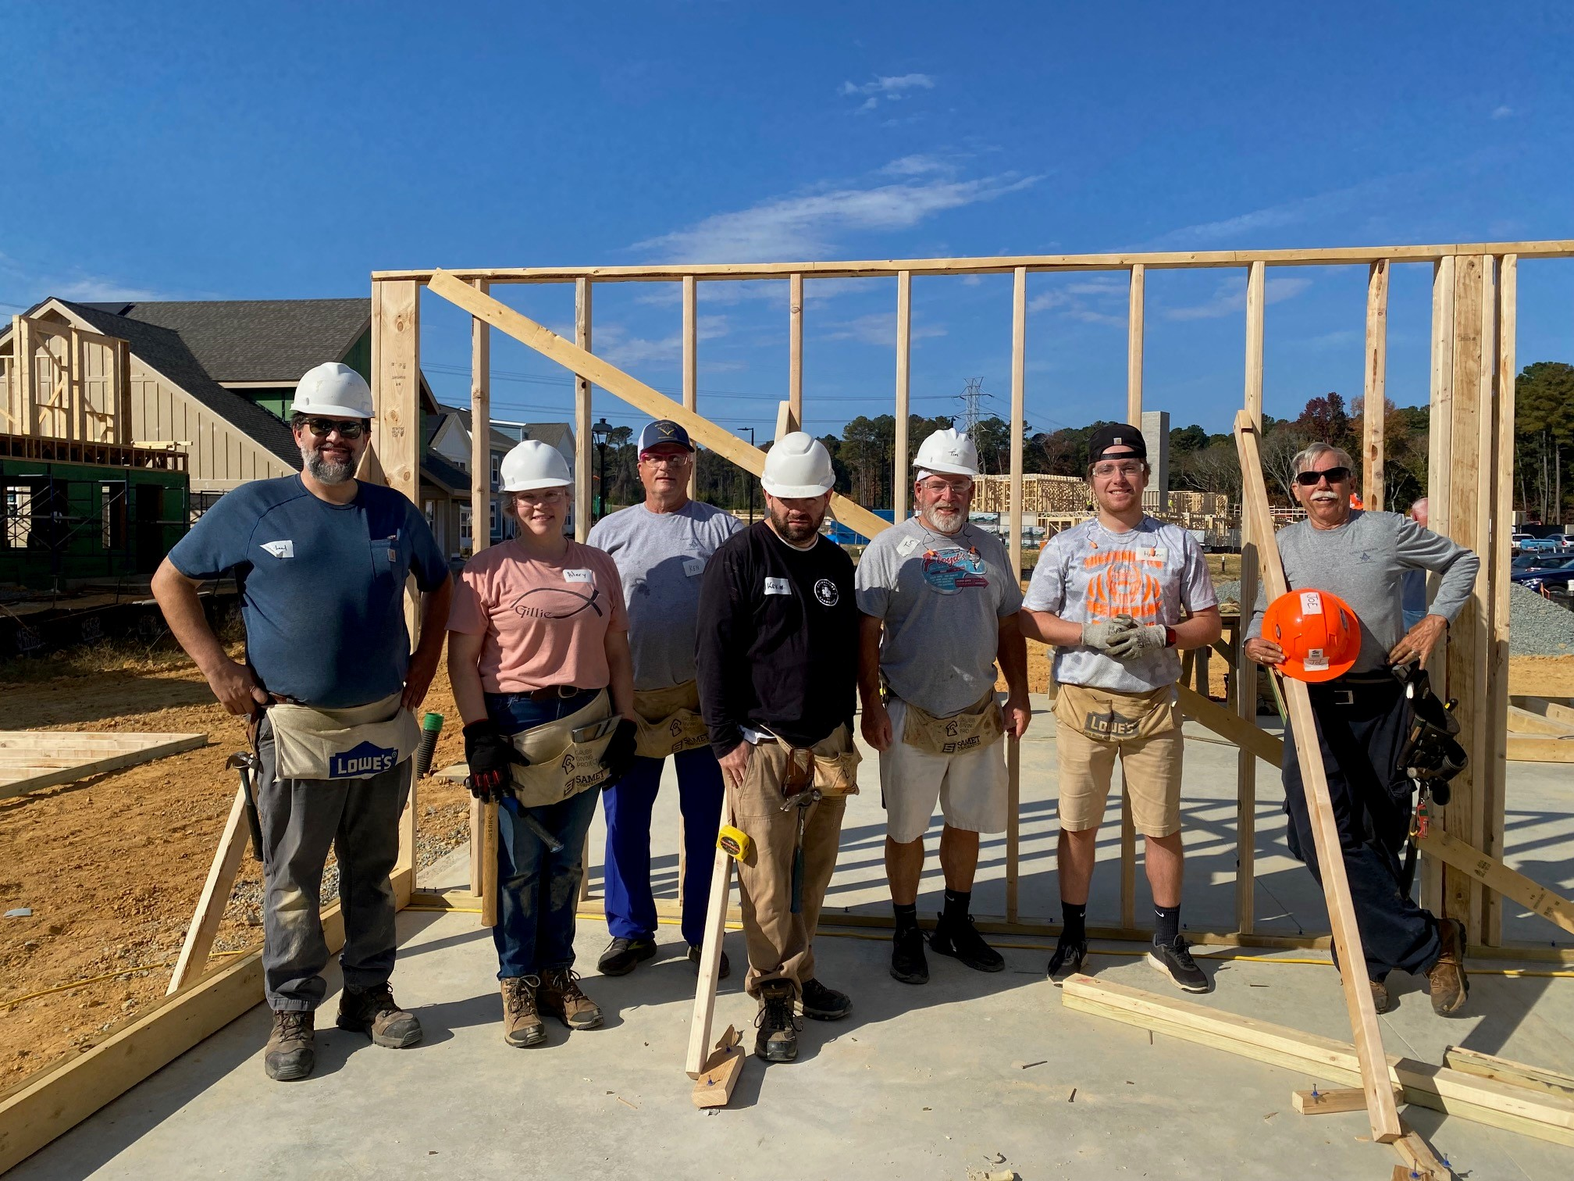  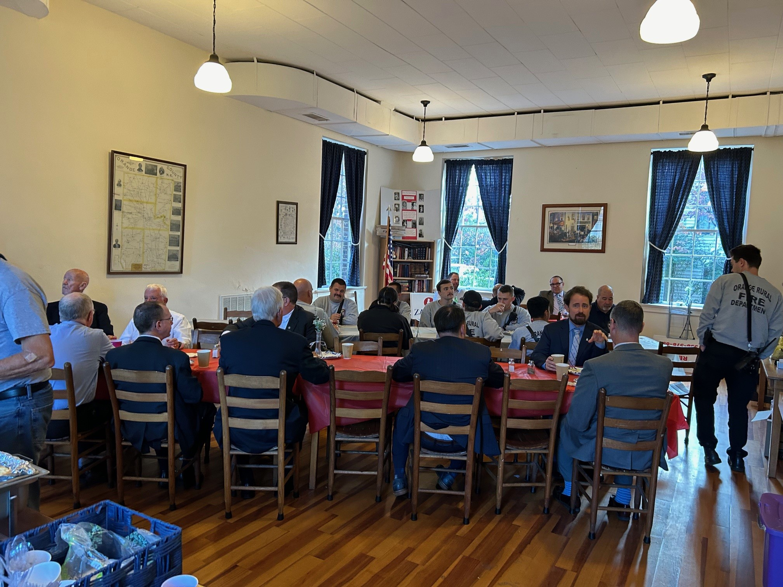
 |    | 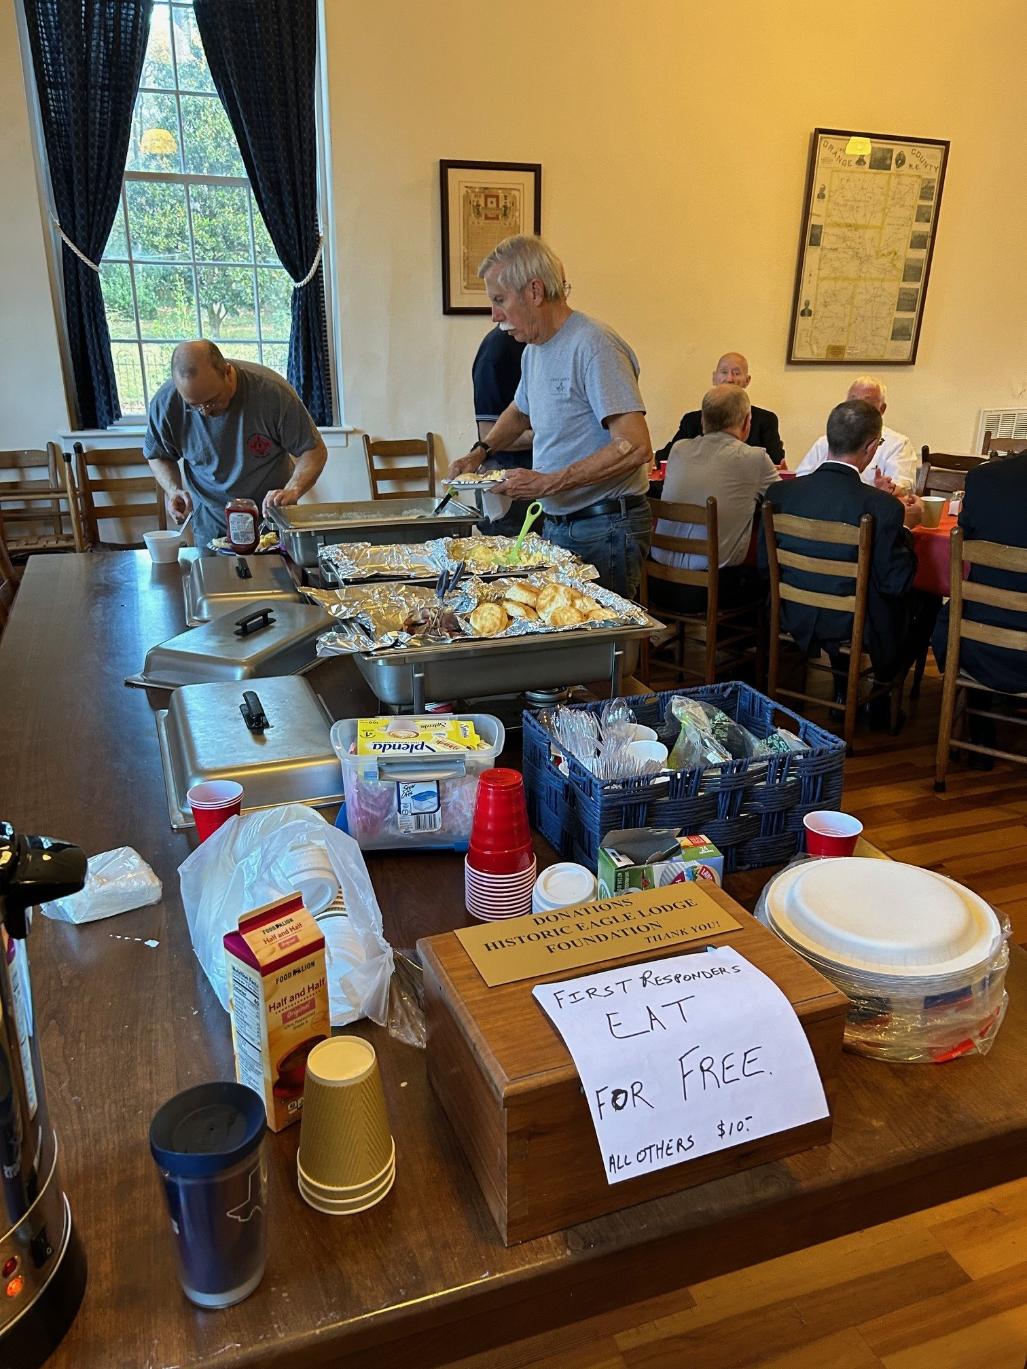  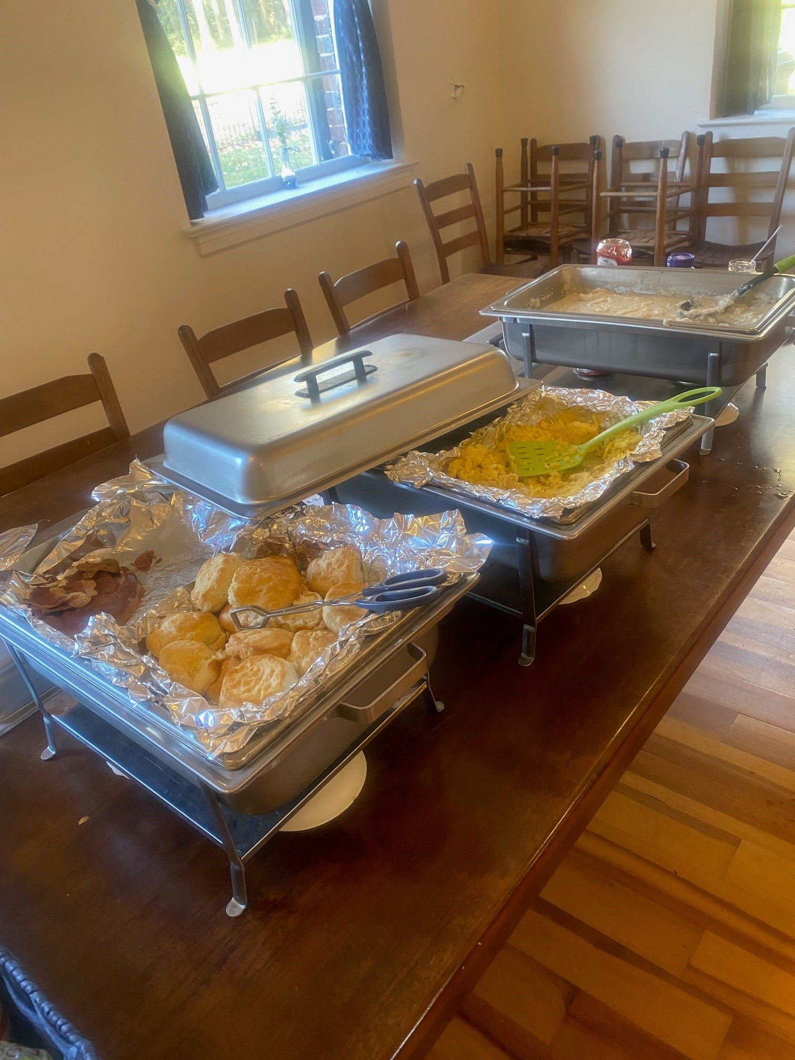

AID AND ASSISTANCE
by William R. Fischer

The duty of "Aid and Assistance" is an important obligation, imposed upon every brother of the order. "To aid and assist all worthy distressed Master Masons, their widows and orphans."
This is according to human nature that will always prefer a friend to a stranger.
Expressed in the language of "Long Tom Coffin":
A messmate before a shipmate.
A shipmate before a stranger.
A stranger before a dog.
As we have the opportunity, let us do well for all men, especially to those of the same house.
We must be ready to aid those who need our help, brothers or strangers.
If those we could have helped and don't, are lost, we lose even more.
For these poor people only lose what they have, but we lose them, our dignity, and our own self worth.



And finally. LOL

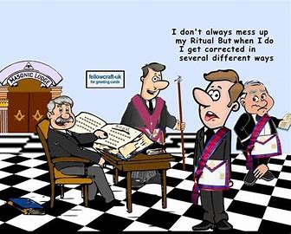

I hope you all have a safe and wonderful Thanksgiving.

Tim

