- 2024 Officers  Tim Walker - Master  336-516-2271  Joe Crane – Sen. Warden  919-593-1177  Michael Verville – Jr. Warden  919-278-0520  Ken Fath – Senior Deacon  Bronte Thompson – Junior Deacon  Jason Ross – Chaplain  WB Barry Deutsch – Tiler  Wade Winstead – Senior Steward  WB Al Serff – Junior Steward  WB Jim Cone - Treasurer  919-384-5305  WB Jeff Borcik - Secretary  919-370-1364  Lodge Info  Website: Eagle19.org  Email:  Eaglelodge19@gmail.com  Facebook  Eagle Lodge #19 AF&AM  P.O. Box 1095  Hillsborough NC 27278-1081 | Eagle Lodge # 19  AF & AM  142 West King St. Hillsborough NC 27278  P.O. Box 1095  Stated communications on the 2nd and 4th Tuesday of each month at 7:30 pm  Supper prior to each meeting at 6:30 pm  Please Join Us at the meal for fun and fellowship  Please text (RSVP) to JW Michael Verville – It helps with meal preparation  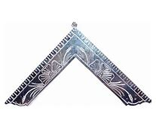  From the East  Greetings Brethren,  Hope this newsletter finds you all well. As I reflect on the recent hurricane and the loss and suffering of those directly impacted, I recognize life’s uncertainty and how quickly things can change regardless of one’s station in life. Let us always serve humbly, speak respectfully and let those who are dear and important to us always know it to be true.  Respectfully,  Tim  There is a first responder’s breakfast being planned that will be held jointly with Lux Libertas Lodge #772 on Saturday morning, November 2nd at Eagle Lodge  We are currently collecting items for our District 19 Shoe Box for Veterans program. The goal is at least 25 boxes. Twenty boxes for male veterans and 5 for female veterans. Any items or donations towards this goal would be highly appreciated.
  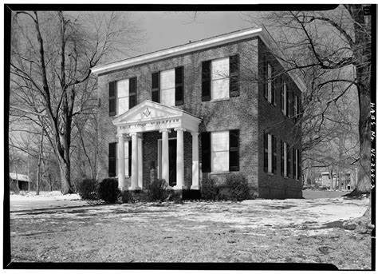
  Historic Eagle Lodge
 | 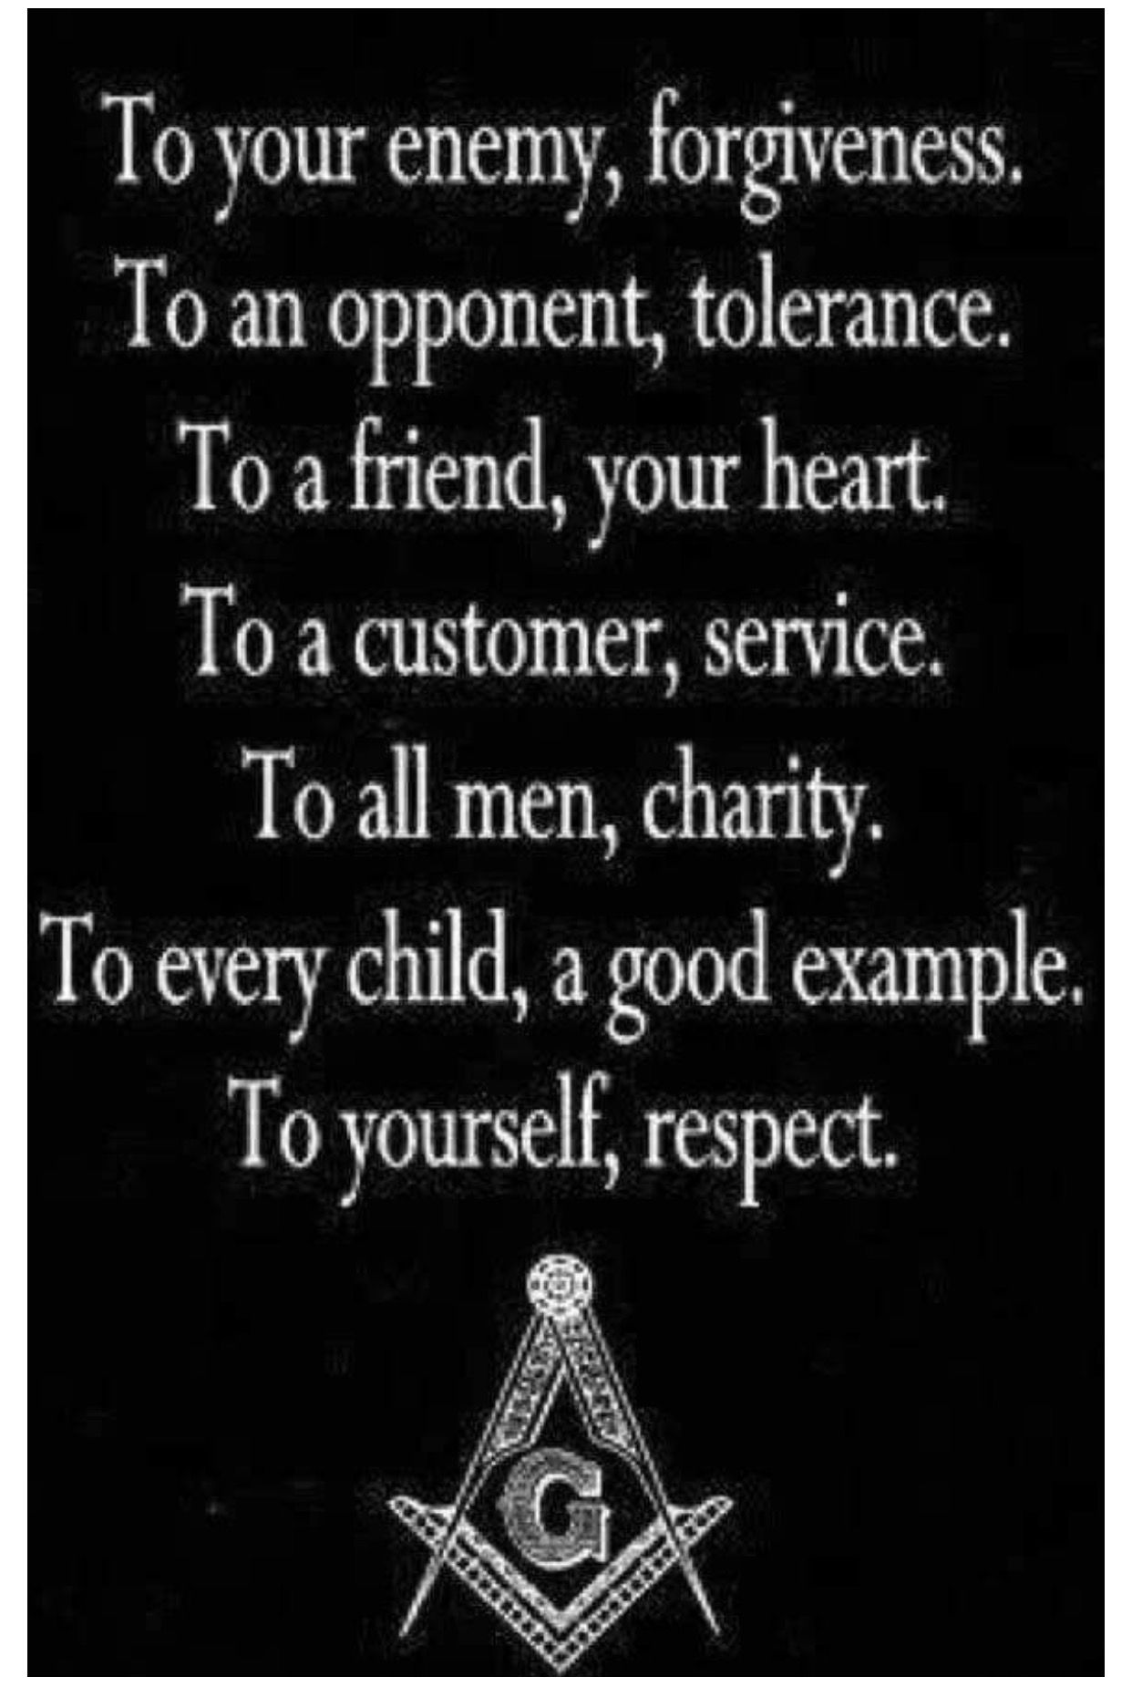 | Happy Birthday to all!  Wesley Cook 1st WB Gregg Phillips 3rd  Brett Horiuchi 6th Joseph Wynn 11th  WB Clifford Raynor 19th WB Joe Major 20th  Eric Altman 26th WB Joseph Smith 27th  Lynwood Wheeley 27th David Whitney 27th  William Cox 27th  Upcoming Events  *Stated Communications on 10/8 and 10/22  *Habitat Build Oct. 26th – Contact SW Joe Crane for details.  *First responders Breakfast Nov 2nd  Sick and Distressed  Please continue to pray for WB Jim Cone’s daughter Mel, as she continues treatment for cancer  The families of those affected by hurricane Helene  Support our fundraiser  (This is an ongoing event, please keep selling)  One brick for $75 Two bricks for $140  Three for $205 Four for $275  How to Order:  Go to Eagle19.org to place your order. Be sure you are happy with your brick design as it will look very similar to the image on your computer when completed.  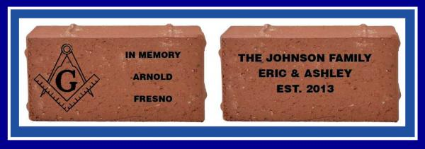  If you have any questions, please contact Barry Deutsch at barryid@gmail.com

