- 2024 Officers  Tim Walker - Master  336-516-2271  Joe Crane – Sen. Warden  919-593-1177  Michael Verville – Jr. Warden  919-278-0520  Ken Fath – Senior Deacon  Bronte Thompson – Junior Deacon  Jason Ross – Chaplain  WB Barry Deutsch – Tiler  Wade Winstead – Senior Steward  WB Al Serff – Junior Steward  WB Jim Cone - Treasurer  919-384-5305  WB Jeff Borcik - Secretary  919-370-1364  Lodge Info  Website: Eagle19.org  Email:  Eaglelodge19@gmail.com  Facebook  Eagle Lodge #19 AF&AM  P.O. Box 1095  Hillsborough NC 27278-1081 | Eagle Lodge # 19  AF & AM  142 West King St. Hillsborough NC 27278  P.O. Box 1095  Stated communications on the 2nd and 4th Tuesday of each month at 7:30 pm  Supper prior to each meeting at 6:30 pm  Please Join Us at the meal for fun and fellowship  Please text (RSVP) to JW Michael Verville – It helps with meal preparation  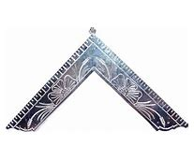  From the East  Greetings Brethren,  September is about half over and I am just getting out the newsletter for this month. My apologies. The last couple of months have been extremely hectic at work. Plus, I just got back from a week at Holden Beach. I sure needed that!  I am looking forward to this last quarter of the year. We still have several items of unfinished business.  We have three brothers who are almost ready to be raised. Three more who are working towards being passed and we have several inquiries. Other lodges are reporting some of the same. Freemasonry is in a state of resurgence it would seem.  We have a Habitat for Humanity build scheduled. We did one back earlier in the year. It was my first ever and I found it to be a fun and rewarding experience, fellowshipping with brothers for a worthy cause. I would highly recommend it to anyone.  There is a first responder’s breakfast being planned that will be held jointly with Lux Libertas Lodge #772 on Saturday morning, November 2nd at Eagle Lodge  The Most worshipful Grand Master of NC will be here November 12th to present a 25-year service award to our very own past Grand Master, MWB Speed Hallman.  We are currently collecting items for our District 19 Shoe Box for Veterans program. The goal is at least 25 boxes. Twenty boxes for male veterans and 5 for female veterans. Any items or donations towards this goal would be highly appreciated.  The Historic Eagle Lodge Golf tournament is almost upon us. We still have room for some teams. ($300) We can still do a tee box sign ($50) if you provide the sign. We have now passed the deadline for our sign person to make any more. Hole sponsorship is still available. ($300) Any and all donations are appreciated and all of these items are tax deductible.  Also, don’t forget Brother Jason Ross is sponsoring a $10,000 hole in one challenge.  Wednesday September 25th ay 9:00 am  - Biscuits and Coffee in the Morning  - Tee it off at 9:00am  - 18 holes of Fun and Fellowship  - Long drive and closest to the pin prizes  - Hot Dog and Hamburger Lunch  - Door prizes  Hope to see you there!
  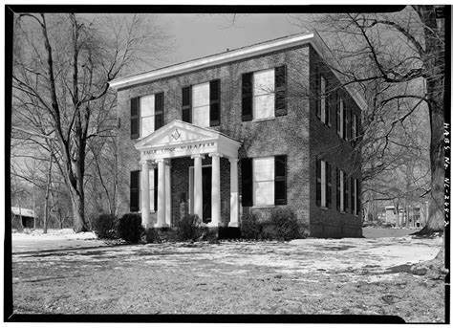
  Historic Eagle Lodge
 | 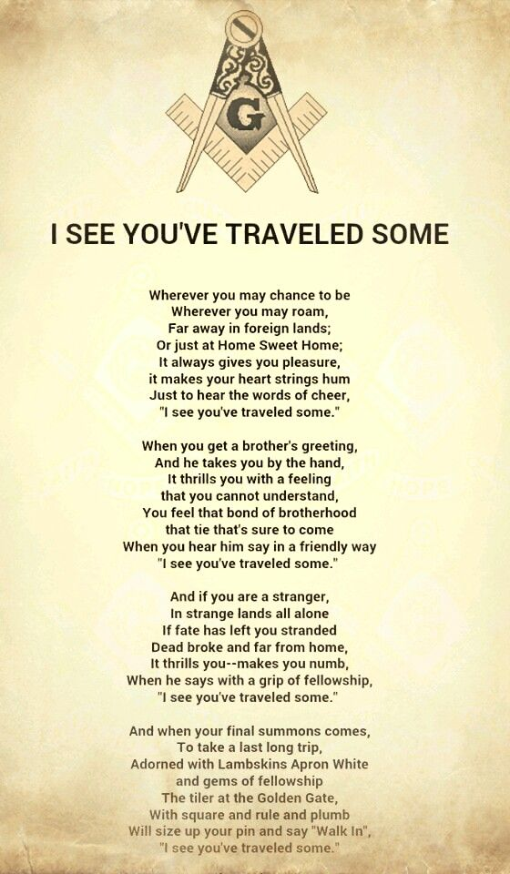 | Happy Birthday to all!  Harold Wagner 3rd Richard Sparrow 5th  Brian Ludwig 5th WB Doug Stevenson 7th  John Serdensky 17th WB Jeff Troccoli 18th  Mirislav Gavazov 20th WB Bill Winecoff 29th  Upcoming Events  *Stated Communications on 9/24 and 10/8  *HELF golf tournament fundraiser 9/25 - Please see flyer on page 4  *Habitat Build Oct. 26th – Contact SW Joe Crane for details.  *First responders Breakfast Nov 2nd  * Grandmaster visit Nov 12th  Sick and Distressed  WB Jim Cone’s daughter is again undergoing treatment for cancer. Please keep her and the Cone family in your prayers.  Support our fundraiser  (This is an ongoing event, please keep selling)  One brick for $75 Two bricks for $140  Three for $205 Four for $275  How to Order:  Go to Eagle19.org to place your order. Be sure you are happy with your brick design as it will look very similar to the image on your computer when completed.  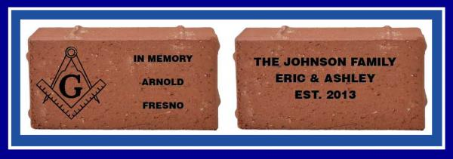  If you have any questions, please contact Barry Deutsch at barryid@gmail.com



