- 2024 Officers  Tim Walker - Master  336-516-2271  Joe Crane – Sen. Warden  919-593-1177  Michael Verville – Jr. Warden  919-278-0520  Ken Fath – Senior Deacon  Bronte Thompson – Junior Deacon  Jason Ross – Chaplain  WB Barry Deutsch – Tiler  Wade Winstead – Senior Steward  WB Al Serff – Junior Steward  WB Jim Cone - Treasurer  919-384-5305  WB Jeff Borcik - Secretary  919-370-1364  Lodge Info  Website: Eagle19.org  Email:  Eaglelodge19@gmail.com  Facebook  Eagle Lodge #19 AF&AM  P.O. Box 1095  Hillsborough NC 27278-1081 | Eagle Lodge # 19  AF & AM  142 West King St. Hillsborough NC 27278  P.O. Box 1095  Stated communications on the 2nd and 4th Tuesday of each month at 7:30 pm  Supper prior to each meeting at 6:30 pm  Please Join Us at the meal for fun and fellowship  Please text (RSVP) to JW Michael Verville – It helps with meal preparation  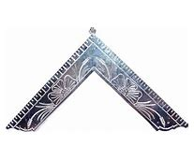  From the East  Greetings Brethren,  As summer plods on and fall steadily approaches, there are several things that are currently claiming our attention. The first is our past masters and widows’ dinner that is taking place Saturday, 8/17/25 at 5:00pm. This is a potluck style meal. Everyone will be bringing their specialty, so it’s going to be delicious.  Please come join us as we recognize the past masters and widows and present some Masonic service awards. If able to attend, please RSVP.  Also vying for our attention, and something that we really need to start pushing, is our charity golf tournament. This tournament is to raise money for the Masonic Home for Children at Oxford, and we also want to take a portion of the funds raised, to facilitate some lodge upkeep and maintenance. Our building is 200 years old and needs a few things done sooner rather than later, so that we can pass it on in good repair to future generations of Masons. Brick repointing and flashing repair are our most urgent needs.  You may ask, “How can I help?”  We still have rooms for more teams. Our goal for a “full” tournament is 30 total four-man teams. The entry fee for a team of 4 is $300. Please talk to your friends that golf, or you may want to play yourself. Please, please mention it around and let’s get this thing filled up.  Selling tee-box signs is another way to get involved. We all know some business people that may like to support local causes and will purchase a sign with their business name on it. Even family members and friends like to get involved and support good causes. Often times they will do an “in memory of” or “in honor of” type of sign. These signs are $50 each. We can’t over sell them. We can sell as many as we can!  We will also be selling hole sponsorships to people who may want to set up a little tent/kiosk on a hole near a tee box and hand out brochures and answer questions about their business. In the past we have had realtors, travel agents, insurance salesmen, car dealerships etc. take advantage of this opportunity. The cost for this is $300.  If you speak with someone and they don’t want to pursue any of these opportunities, point out that we will accept donations and no amount is too small.  Also, during your sales presentation, please mention that this fundraiser is being run by our foundation “HELF” and that all donations are tax deductible.  Historic Eagle Lodge Foundation  HELF was founded in 2005 to maintain, preserve and protect the historic building and grounds. Since that time, HELF has raised funds for ongoing maintenance and preservation projects such as repointing exterior brickwork, repairing plaster and paint in the main lodge room, recovering theater seats, repair of deteriorated floors, and more.  Let’s all please become active and involved in this project and reach the $20,000 goal that has been set. With some effort on everyone’s part, that goal is very obtainable.  Thanks,  Tim Walker
  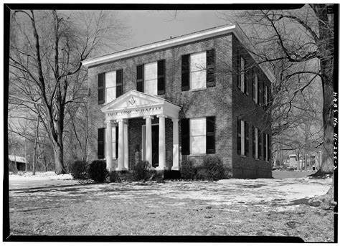
  Historic Eagle Lodge
BONE BOX  by William R. Fischer  In the early lectures of the last century, now obsolete these questions were used as a test:  Q - Have you any keys to the secrets of a Mason?  A - Yes  Q - Where do you keep them?  A - In a bone box, that neither opens nor shuts but with Ivory Keys.  The bone box is the mouth, the Ivory Keys the teeth. The key to the secrets is the tongue. | August Birthdays – Happy Birthday to all!  WB James Rafferty 11th Rodney Mangum 11th  Williard Causey 12th John Austin 13th  Francis Redd 15th WB Charles King 16th  WB Thad Farlow 23rd Timothy Smith 27th  Upcoming Events  Stated Communications on 8/13 and 8/27  Past Masters and Widows dinner 8/17 at 5:00pm  HELF golf tournament fundraiser 9/25 - Please see flyer on page 4.  Sick and Distressed  WB Jim Cone’s daughter is again undergoing treatment for cancer. Please keep her and the Cone family in your prayers  Support our fundraiser  (This is an ongoing event, please keep selling)  One brick for $75 Two bricks for $140  Three for $205 Four for $275  How to Order:  Go to Eagle19.org to place your order. Be sure you are happy with your brick design as it will look very similar to the image on your computer when completed.  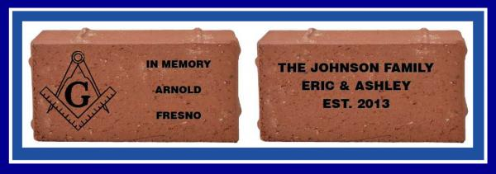  If you have any questions, please contact Barry Deutsch at barryid@gmail.com





