- 2024 Officers  Tim Walker - Master  336-516-2271  Joe Crane – Sen. Warden  919-593-1177  Michael Verville – Jr. Warden  919-278-0520  Ken Fath – Senior Deacon  Bronte Thompson – Junior Deacon  Jason Ross – Chaplain  WB Barry Deutsch – Tiler  Wade Winstead – Senior Steward  WB Al Serff – Junior Steward  WB Jim Cone - Treasurer  919-384-5305  WB Jeff Borcik - Secretary  919-370-1364  Lodge Info  Website: Eagle19.org  Email:  Eaglelodge19@gmail.com  Facebook  Eagle Lodge #19 AF&AM  P.O. Box 1095  Hillsborough NC 27278-1081 | Eagle Lodge # 19  AF & AM  142 West King St. Hillsborough NC 27278  P.O. Box 1095  Stated communications on the 2nd and 4th Tuesday of each month at 7:30 pm  Supper prior to each meeting at 6:30 pm  Please Join Us at the meal for fun and fellowship  Please text (RSVP) to JW Michael Verville – It helps with meal preparation  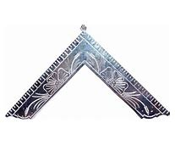  From the East  Greetings Brethren,  Wow, just wow! The year is half over. There are a lot of good things happening in the lodge. At our last stated communication, we had an Entered Apprentice degree and initiated 5 new members. That’s correct, five. We will be initiating another this coming Thursday. It seems as if we are experiencing a resurgence in Freemasonry, in and around the area. Bingham Lodge in Mebane has done ten plus recently, and I’ve heard brothers from other lodges mention doing first degrees as well. This is awesome as we continue the pursuit and tradition of making good men better.  We recently participated in a Habitat for Humanity build. It was the most fun and rewarding half day I have spent recently. I would like to thank our Sen Warden, Bro. Joe Crane for having the idea, and coordinating for us to be able to participate. I would highly encourage you, if you ever get the opportunity to participate, do it  The front steps have been completed and look awesome. Thank you, WB Joe Major, for seeing this project through from start to finish. Job well done.  That leads us right into the walkway project. We will be having the walkway leveled up and repaired in certain areas and will be installing our commemorative bricks. This project is scheduled to be completed in the month of July if all goes well. For any that may be unaware, the commemorative bricks are a Helf fundraiser for the lodge. Bricks can still be purchased / sold. The information for that is on the bottom of page 3 of this newsletter  As most are aware, our Historic, beloved Lodge building is 200 years old. She is in pretty good shape for her age but is in need of a significant amount of repointing of the bricks and some exterior repair to some flashing. To that end, we are holding a golf tournament as a Historic Eagle Lodge Foundation fundraiser. This tournament is scheduled for Wednesday, September 25th at Quaker Creek Golf Course in Mebane.  Historic Eagle Lodge Foundation  HELF was founded in 2005 to maintain, preserve and protect the historic building and grounds. Since that time, HELF has raised funds for ongoing maintenance and preservation projects such as repointing exterior brickwork, repairing plaster and paint in the main lodge room, recovering theater seats, repair of deteriorated floors, and more.  We can use all the help we can get as I have set a lofty goal of raising $20,000 from this event.  If you think there is nothing you can do to help with this project, you’re probably wrong. Please get involved and let’s knock this out of the park!!  I would like to continue to ask for any brother who may not have sat in lodge lately, to please come out and join us for a meal and Stated Communication. If you haven’t had the opportunity to see it, we painted the ceiling and the moulding in the lodge room blue and gold. It might not sound like much, but trust me when I tell you, it looks fantastic!  I hope you all have a joyful and blessed Independence Day and I hope to see you soon.  Tim Walker – Master Eagle #19
  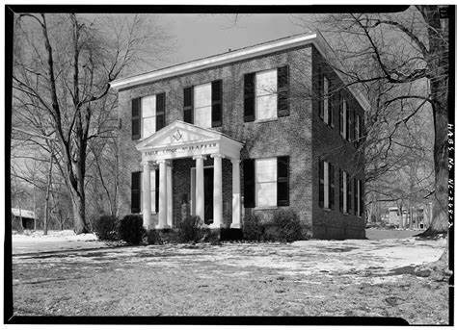
  Historic Eagle Lodge
ROUGH AND PERFECT ASHLARS  Masons hear much about rough and perfect ashlars. They are described in the lecture of the Entered Apprentice degree. We know what use was made of rough and perfect ashlars in the old operative days; but in Speculative Masonry we often refer to our lodge Brothers figuratively as rough and perfect ashlars, although we never had anyone who would fully qualify for the latter description.  A rough ashlar is not a physically faulty stone. In Freemasonry it is as substantial as the perfect ashlar, necessarily so, for from it the perfect ashlar is fashioned. Used as a part of a structure, it owes no apology to the perfectly shaped and sometimes polished stone. In structures of stone there may be more rough ashlars than finished stones, just as in Speculative Freemasonry there are a lesser number of informed Brethren who are qualified to give freely of wisdom to the many eager to learn.  We can have in our membership few, if any, approaching the perfection of a perfect ashlar. We are fortunate to have so many to whom we may fondly refer as faithful rough ashlars who are the support of the lodges. | June Birthdays – Happy Birthday to all!  John Prosseda 14th Steve Lynch 16th  Clyde Wagner 14th Bob Patten 17th  Stephen Mitchell 31st  WB Raul Herrera 23rd  Upcoming Events  Stated Communications on 7/9 and 7/23  Entered Apprentice Degree 7/11 at 7pm  Historic Richmond Randolph Lodge Visit 7/13. WB Jim Cone has details  HELF golf tournament fundraiser 9/25  Sick and Distressed  WB Al Serff’s wife Vivien passed on 6/26. Please continue to keep him and his family in your thoughts and prayers.  Support our fundraiser  (This is an ongoing event, please keep selling)  One brick for $75 Two bricks for $140  Three for $205 Four for $275  How to Order:  Go to Eagle19.org to place your order. Be sure you are happy with your brick design as it will look very similar to the image on your computer when completed.  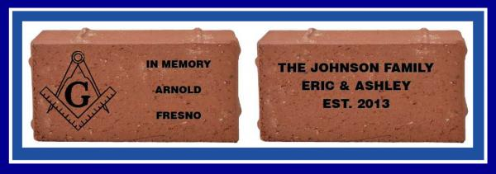  If you have any questions, please contact Barry Deutsch at barryid@gmail.com



