- 2024 Officers  Tim Walker - Master  336-516-2271  Joe Crane – Sen. Warden  919-593-1177  Michael Verville – Jr. Warden  919-278-0520  Ken Fath – Senior Deacon  Bronte Thompson – Junior Deacon  Jason Ross – Chaplain  WB Barry Deutsch – Tiler  Wade Winstead – Senior Steward  WB Al Serff – Junior Steward  WB Jim Cone - Treasurer  919-384-5305  WB Jeff Borcik - Secretary  919-370-1364  Lodge Info  Website: Eagle19.org  Email:  Eaglelodge19@gmail.com  Facebook  Eagle Lodge #19 AF&AM  P.O. Box 1095  Hillsborough NC 27278-1081 | Eagle Lodge # 19  AF & AM  142 West King St. Hillsborough NC 27278  P.O. Box 1095  Stated communications on the 2nd and 4th Tuesday of each month at 7:30 pm  Supper prior to each meeting at 6:30 pm  Please Join Us at the meal for fun and fellowship  Please text (RSVP) to JW Michael Verville – It helps with meal preparation    From the East  Greetings Brethren,  Sorry to be getting this out to you a little late this month. For those of you who don’t know, I own a landscape company and this is an extremely busy time of year for us.  I have been pretty consistent this year on inviting brothers who may have not have attended in a while to come out and sit in your home lodge with us. I would like to continue that effort and let you know that you are welcome and would love to see you! Please let me know if there is something keeping you away that I can help rectify.  I would also like to thank the brothers who come regularly. I have been a member of Eagle since 2019 and there has been a core group of guys that have attended consistently. They are the brothers who are filling in chairs when needed, cleaning and maintaining the lodge, coaching candidates and just overall keeping Eagle Lodge alive and vibrant. Brothers you may not hear this often enough, but your efforts are appreciated by many and especially by me.  Tim Walker – Master Eagle #19
  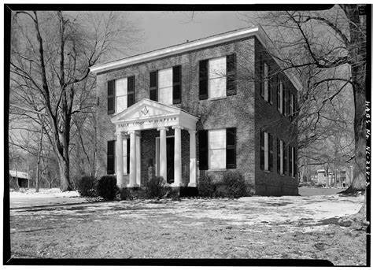
  Historic Eagle Lodge
 | May Birthdays – Happy Birthday to all!  Alan Forest 11th  Danny Tuck 14th  Jessie Brown 18th  WB Raul Herrera 23rd  Upcoming Events  Stated Communications on 5/14 and 5/28  MWB Speed Hallman will be delivering our Masonic Education for the 5/28 stated communication.  Sick and Distressed  WB John Serdensky’s wife Joan recently passed. There was a memorial service for her on 5/4. Please keep brother John and his family in your prayers during this time of loss.  - Fundraiser  Support our fundraiser  (This is an ongoing event, please keep selling)  One brick for $75 Two bricks for $140  Three for $205 Four for $275  How to Order:  Go to Eagle19.org to place your order. Be sure you are happy with your brick design as it will look very similar to the image on your computer when completed.  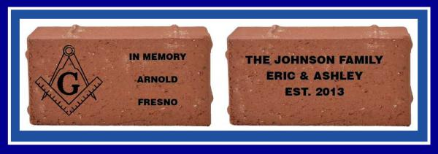  If you have any questions, please contact Barry Deutsch at barryid@gmail.com
    - //////////////////////////////////////////////////////
  Just a quick update on the front steps project. Yesterday, 5/4, the large steps and hip stones were put into place. The operative mason crew has only a few things left to do and our steps will be back functional and historically accurate. As our brother Jason Ross would say, Yeeee-Haaaa!!
  I will post some before and after pictures soon.
  That will bring us to the second phase of that project which is to re-do the front walk and install our new commemorative brick pavers.
  Just as a reminder this is an ongoing fund raiser and we can continue to keep selling these. See the details on this page to the right.
  I have bought two bricks in memory of loved ones. If we can sell 5 bricks in the month of May, I will purchase another. If we can squeeze out 10, I’ll do two.
  WB Barry, let me know as soon as we accomplish this goal and I will get mine ordered.
  Brothers, I would like to designate May and June as bring a friend to eat months. Invite anyone you think may be interested in Masonry and let them come out and meet the crew. If we get visitors, everyone please introduce yourself, shake their hand and thank them for coming>

A CIVIL WAR STORY
by John Hohenstein, Zerubbabel Lodge #15, Savannah, Georgia

It was a time not long after Fort Sumter and The War of Northern Aggression was well under way. The Yankees, as they are still wont to do, had promptly flocked to Hilton Head and Tybee Islands, the barrier islands on opposite sides of the mouth of the Savannah River. The Savannah Folks didn't mind much that the Yankees had stolen the good beaches, for the water was still a bit cool for Southern preferences and, besides, they knew the gnats and mosquitoes would teach the Yankees a lesson they'd never forget. So, the Southerners, as Southerners are wont to do sometimes, just waited.
They didn't have to wait very long before the Yankees on Hilton Head sent out a messenger under a white flag.
It seemed that the Yankees had among them a young fellow who had passed through the Fellow Craft Degree before shipping out. The Yanks were just sitting around slapping gnats when it occurred to one of them that, just maybe, there was a nearby lodge that could test him in the Fellow Craft Degree and raise him to that of a Master Mason.
As luck would have it, there was indeed a lodge in Savannah that would soon be having a Master’s Degree.
One morning, not too many days later, a detail of Confederate Cavalry slipped across the Savannah River into South Carolina and traveled through Bluffton to the shore opposite Hilton Head Island.
From there they escorted one Fellow Craft Mason and, I believe, a number of Master Masons of the Northern Persuasion, safely through the Confederate Lines and back through about 35 miles of Confederate defenses to Savannah where the candidate and his witnesses were delivered into the lodge.
The records note that this Brother was indeed proficient in the Fellow Craft Degree and he was raised to the Degree of a Master Mason.
That night another detail of Confederate Cavalry, no doubt Brothers to a man, slipped back across the Savannah River and safely escorted their brothers back to Hilton Head.
Anyway, I have loved this story since the first time I heard it. It clearly demonstrates that, at the darkest period in our Nation's history, when brothers were killing brothers, Brothers could still be Brothers.



