May 2024 Trestle Board

Stated Communications

May 14th, 2024 Lodge opens at 7:30 Dinner at 6:30

May 28th, 2024 Lodge opens at 7:30 Dinner at 6:30

Master Mike Carlow Winger169@gmail.com 623-229-7450

Sr. Warden Brian Curvin briancurvin@gmail.com 704-929-1500

Jr. Warden Dayne Marsh Funeraldirectordayne@gmail.com 828-855-8278

Secretary David Wendt wendt704@roadrunner.com 704-881-2156

Treasurer John Raley raleyjr@aol.com 952-221-0927

Chaplin Blue Weber foxhollowfarmnc@gmail.com 704-661-7696

Sr. Deacon Max Gunter fastframe375@gmail.com 704-657-8562

Jr. Deacon Donovan Arnold pfcarnolddr@gmail.com 252-722-4208

Sr. Steward Will Jones wrjones357@pm.me 828-546-6767

Jr. Steward Ralph Miller ralphmiller322@gmail.com 828-855-4194

Tyler

Greetings from the East:

Brothers….

We will have an Entered Apprentice Degree at our first meeting in May. Please join us in welcoming our newest EA.

Tragedy has stuck our community with the senseless killing of four Officers. Please join us in supporting the families of the fallen officers during a fund-raising event on May 11th. Details are provided below under Upcoming Events.

Upcoming Events:

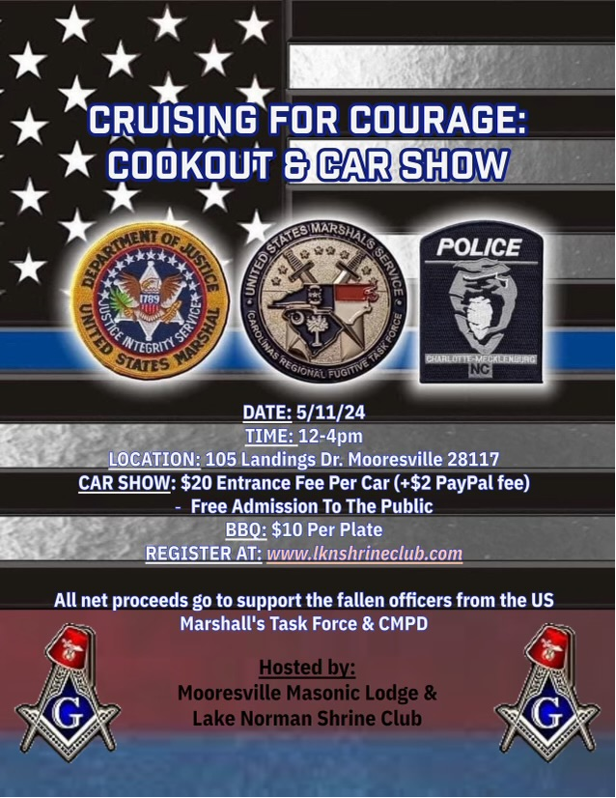

From the South:

May 14th Dinner

Pizza, Bread sticks, Salad

May 28th Dinner

Hamburgers, Hot dogs, Chips

From the Secretaries Desk:

Just a reminder that we have completed our first quarter of this year and thirty of our members have failed to pay their annual dues which were due the first of this year. Please remember….we have bills to pay and we are expected to be self sustaining by the Code.

Masonic Education:

What has Masonry done for the world?

Freemasonry has done more for the world than most people, including Masons, realize. Historians have generally paid little attention to Masonry but are now realizing that Freemasonry runs as a thread through many of the events which have shaped the political, economic, cultural, and social world we know today. Let’s explore some of this!

Individualism

We take our individualism for granted today. We dress the way we want, fix our hair the way we want, say what we want, eat what we want, and read what we want. But it wasn’t always that way. A major first step toward individualism was taken in A.D. 1230, when the stone masons were ordered by the Church to shave off their beards and cut their hair short. One of the first sit down strikes in Europe was the result, with the masons insisting on the right to dress as they wished. The Church finally had to give in, and the first blow for individualism was struck.

Throughout the Enlightenment (late 1600’s through mid 1700’s) the fraternity actively pressed for and taught its members the revolutionary idea that each man and woman was entitled to respect as an individual. That idea spread from Masonic Lodge is to society as a whole.

Democracy

Historians now realize that Masonic Lodges in Europe served as the first models of democracy, models which later spread to governments. Members in Lodges made their own by-laws and elected their own leaders. No place else in society was that true. The very idea of elections, unsupervised by religious or civic authority, was unheard of – except in the Lodge. It is not too much to say that the model of democracy which later was finalized in the United States and now exists in many nations of the world was an invention of the Masonic Lodge.

Masonry came to North America in the early 1700’s. Many of the political debates about America’s future took place in Masonic Lodges, involving such Masons as George Washington, Benjamin Franklin, Paul Revere, and Joseph Warren. Those men were not only involved as individuals in the founding of America, but their Lodges were deeply involved in creating the new nation, ratifying the Bill of Rights and establishing democracy as we know it today.

Source: Masonic Information Center

